The Problem Play
- It took King Polixenes 23,880 minutes to travel from Bohemia to Sicily. He needs to travel there and back. How many hours will it take him?
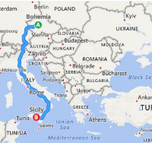
Work it out:
Estimate the answer:

- Hermione’s first pregnancy lasted 281 days and her second pregnancy lasted 275 days. In the first pregnancy, she had morning sickness for 24 days and in the second pregnancy, the sickness lasted 37 days. How many days did Hermione not feel sick for altogether?
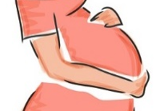
Work it out:
Estimate the answer:

- Dion and Cleomenes return from their visit to the Oracle in Delphi. They travel 607 miles from Delphi to the Greek coast, 919 miles across the Ionian Sea and a further 154 miles on land to Sicily. They travelled 56 miles each day. Which months of the year would fit this trip perfectly? (just the right amount of days!)

Work it out:
Estimate the answer:

- Antigonus lays gold and jewels beside baby Perdita as he leaves her in woodland in Bohemia. Each piece of gold was worth 394 Florin. There were 11 pieces of gold. Each ruby was worth 409 Florin. There were 9 rubies. How many Florins were the rubies and the gold worth?

Work it out:
Estimate the answer:

- The Shepherd and the Clown, who find the baby princess, Perdita count that there are 4872 jewels laid next to her on the ground. 1788 of the jewels were pearls. The rest are equal numbers of rubies, sapphires and emeralds. How many of each were there?
Estimate the answer:

Work it out:

