Twelfth Night
Act 3
Year 3 and 4 missing number daggers

Context

In this act we see Malvolio parading in front of Olivia in a very strange manner, smiling and wearing cross-gartered yellow stockings. Olivia believes her servant to be unwell and asks the other members of her household to take care of him. Saying that he has gone mad, they decide to look him up in a dark room.

Jealous of Olivia’s affection towards Cesario, Sir Toby tricks Sir Andrew into challenging him to a duel. Before the clash can begin, Sebastian’s friend Antonio arrives on scene and stops the fighting. Orsino’s officers then arrive to arrest Antonio who now begs Cesario for help, mistaking him for his good friend Sebastian. Viola denies knowing Antonio, and Antonio is dragged off, crying out that Sebastian has betrayed him. Suddenly, Viola has newfound hope that her brother may be alive.

Maths

These number puzzles are inspired by the duel between Sir Andrew and Sebastian in this act.

LI: To count from 0 in multiples of 50 and 100; find 10 or 100 more or less than a given number (Y3).
LI: To find 1,000 more or less than a given number (Y4).

Counting in 1S AND 10s Puzzles

Find the missing numbers in this 100 square.
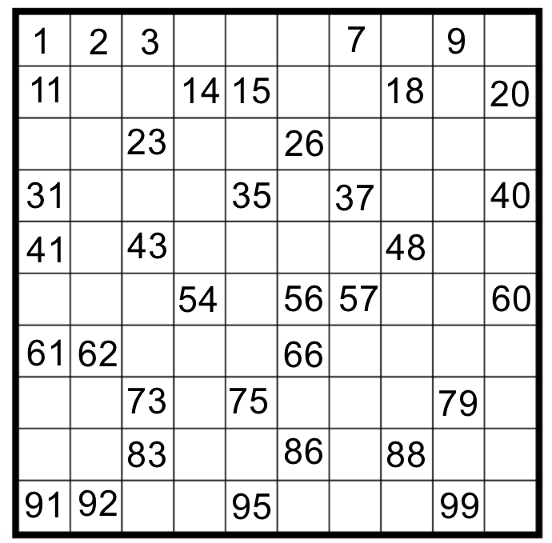

Counting in 1S AND 10s Puzzles

Find the missing numbers in these parts of the 100 square daggers.
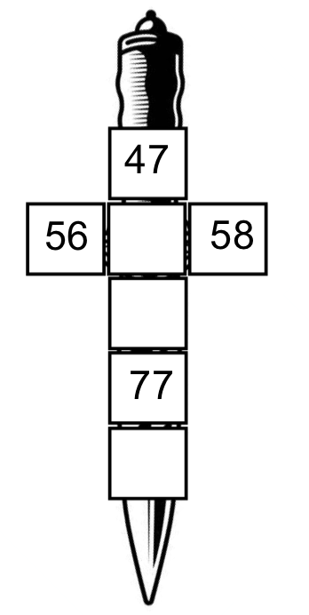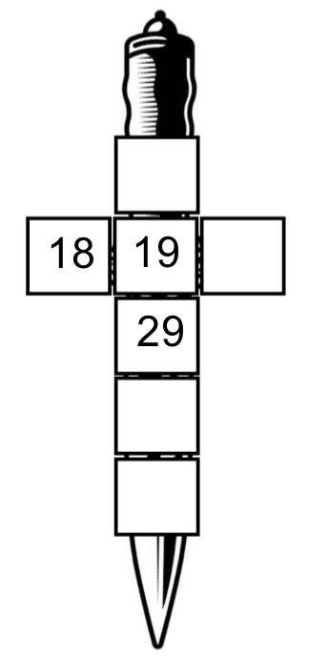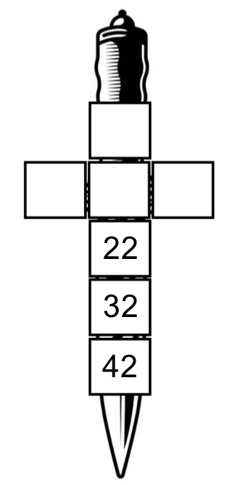

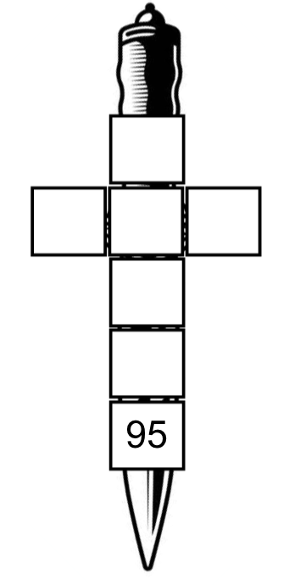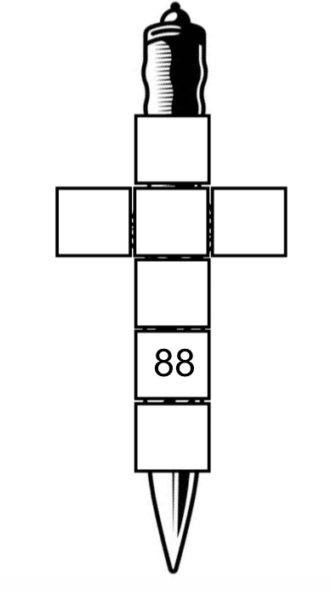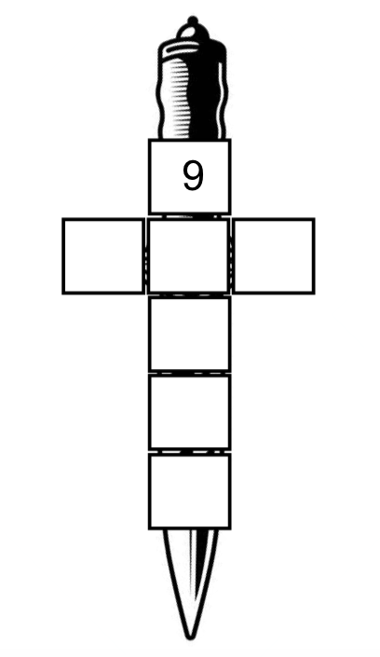

Counting in 1S AND 10s Puzzles

Find the missing numbers in these parts of the 100 square daggers.

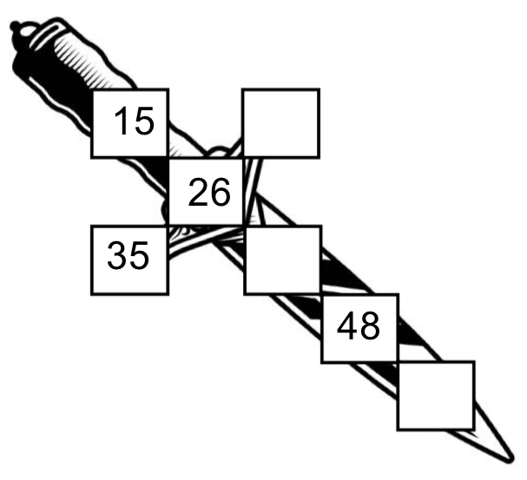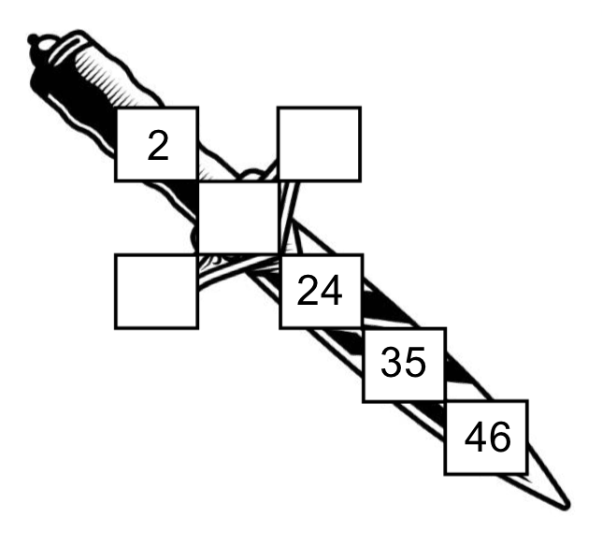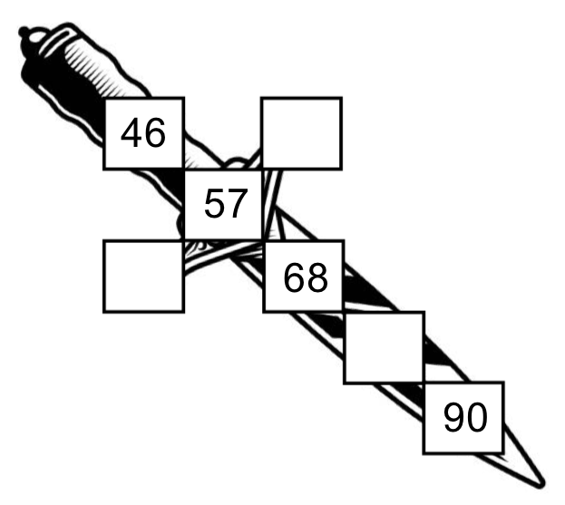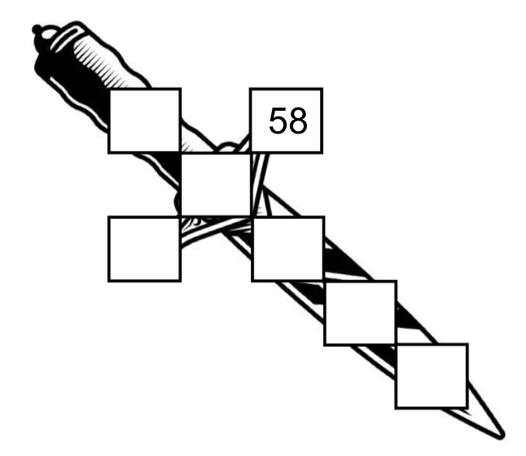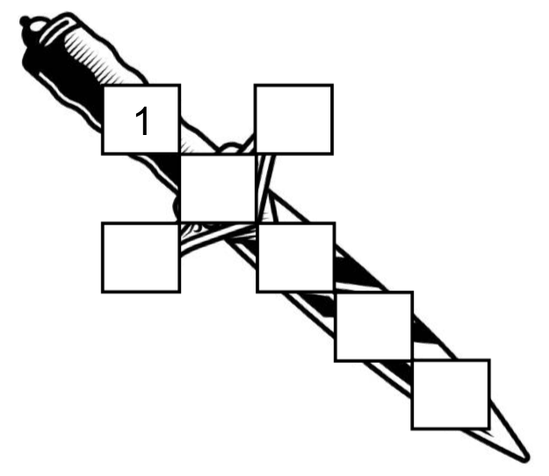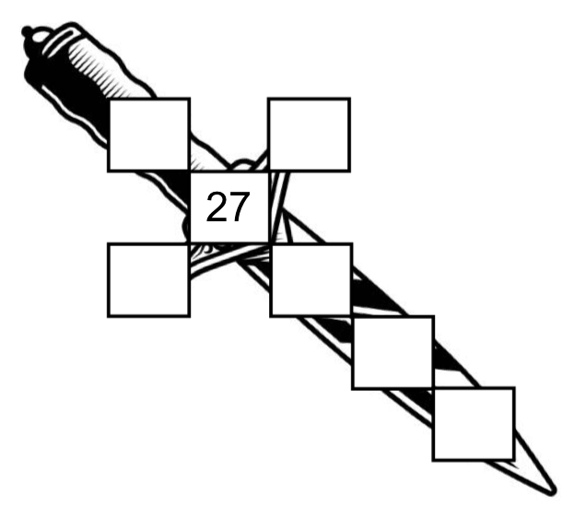

Counting in 10s and 100s puzzles

Find the missing numbers in this 1,000 square.

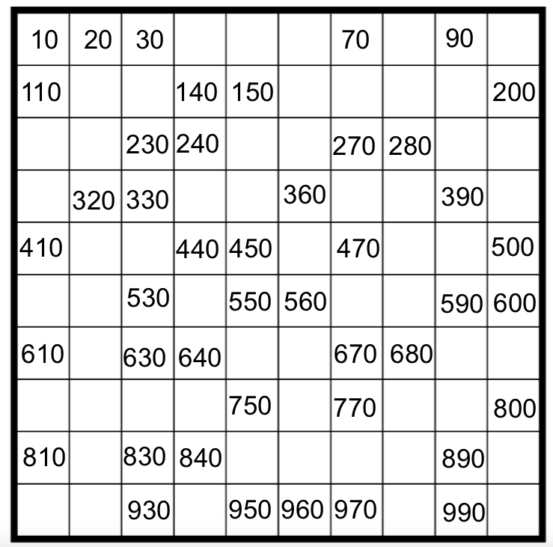

Counting in 10s and 100s puzzles

Find the missing numbers in these parts of the 1,000 square daggers.

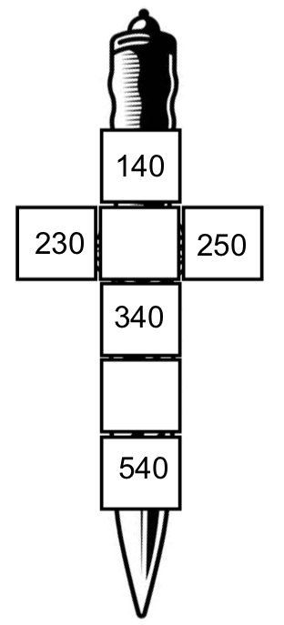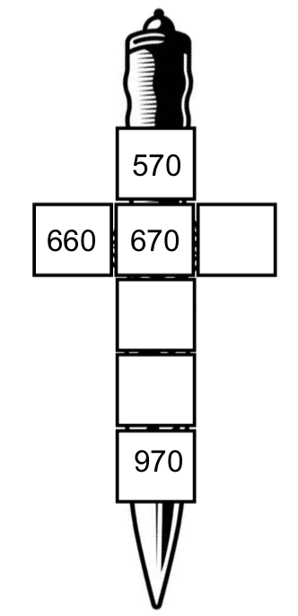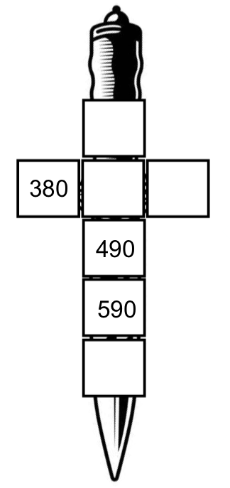

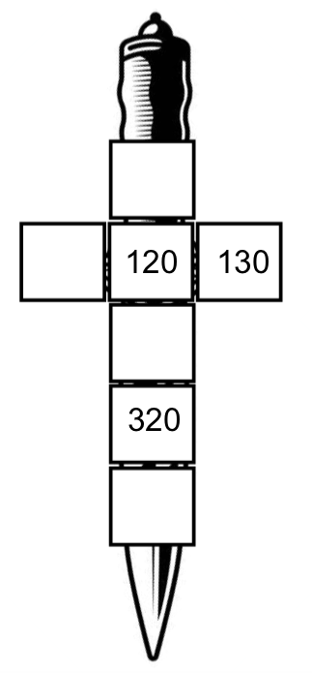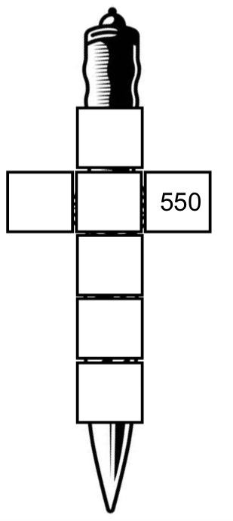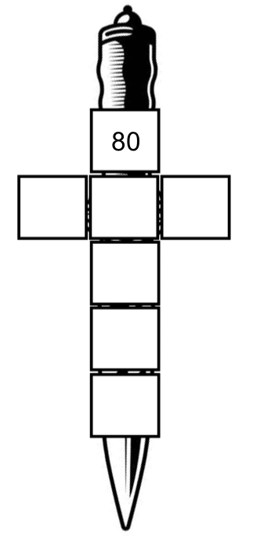

Counting in 10s and 100s puzzles

Find the missing numbers in these parts of the 1,000 square daggers.

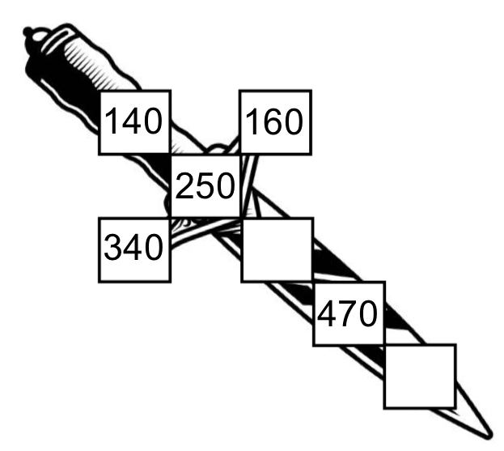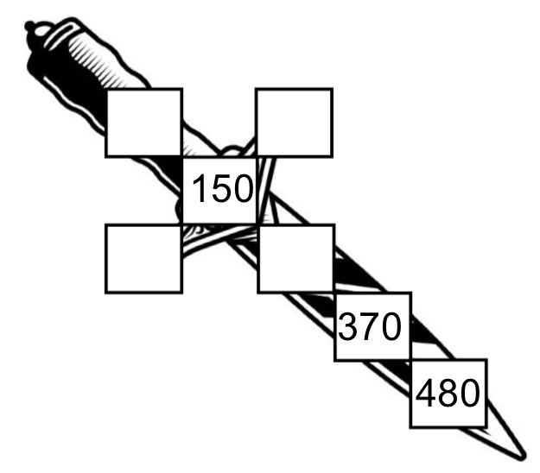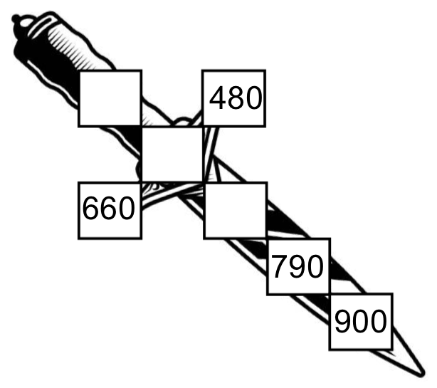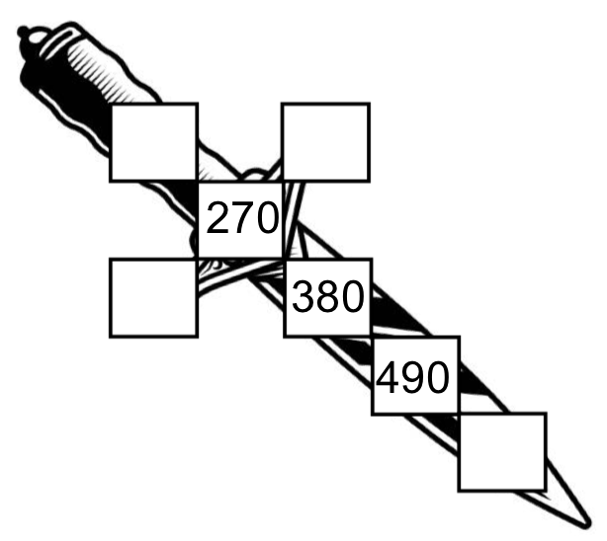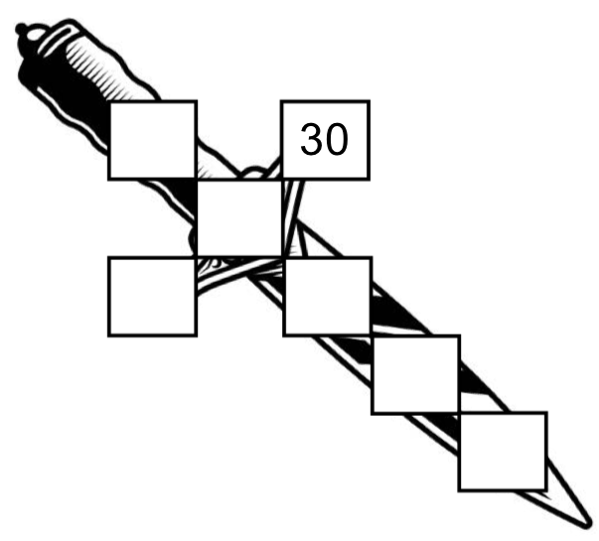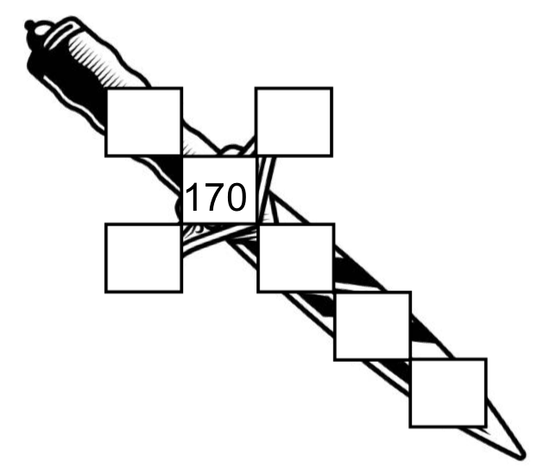
Counting in 100S AND 1,000s Puzzles

Find the missing numbers in this 10,000 square.

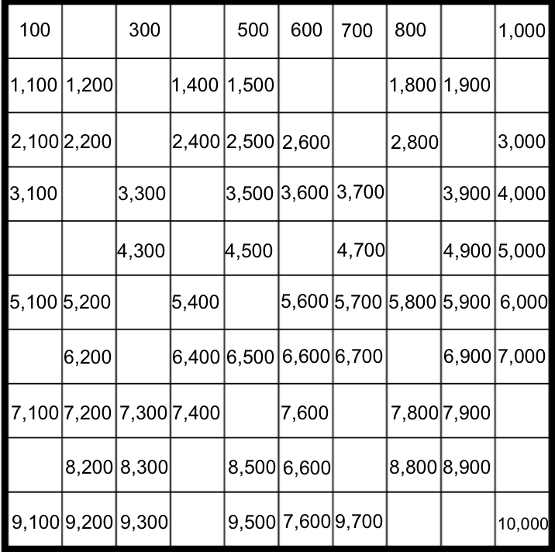

Counting in 100S AND 1,000s Puzzles

Find the missing numbers in these parts of the 1,000 square daggers.

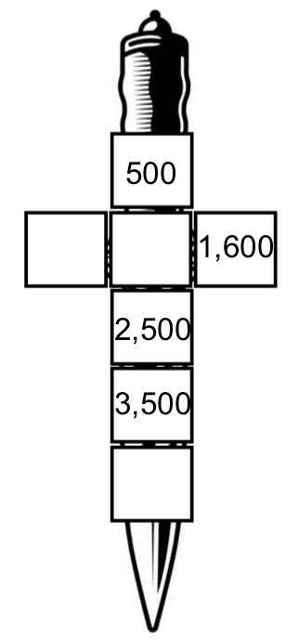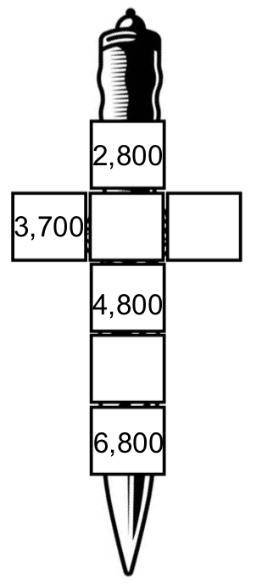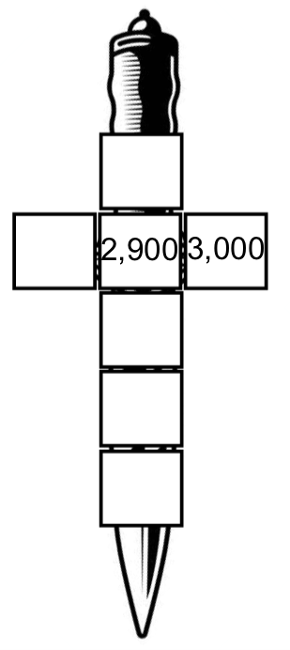

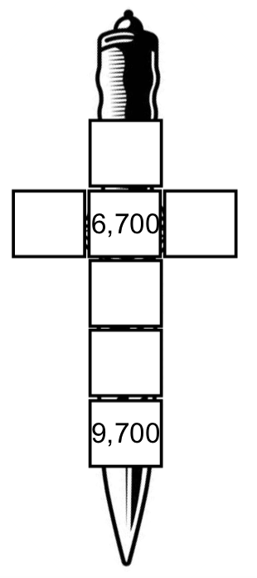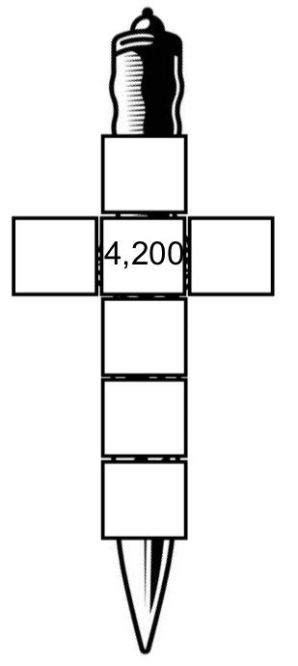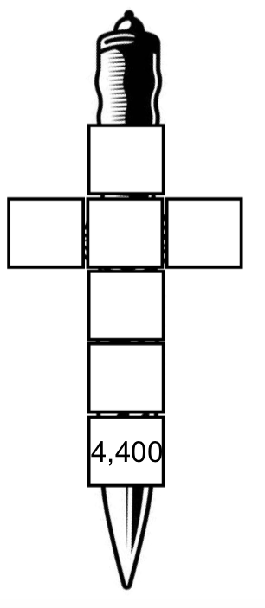

Counting in 100S AND 1,000s Puzzles

Find the missing numbers in these parts of the 1,000 square daggers.

