Area of Mosaics

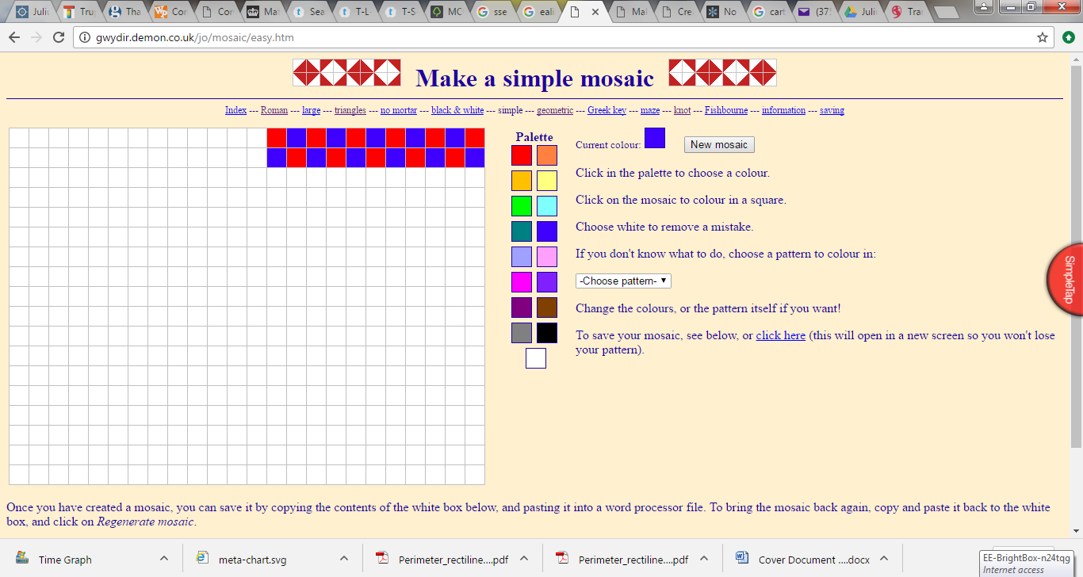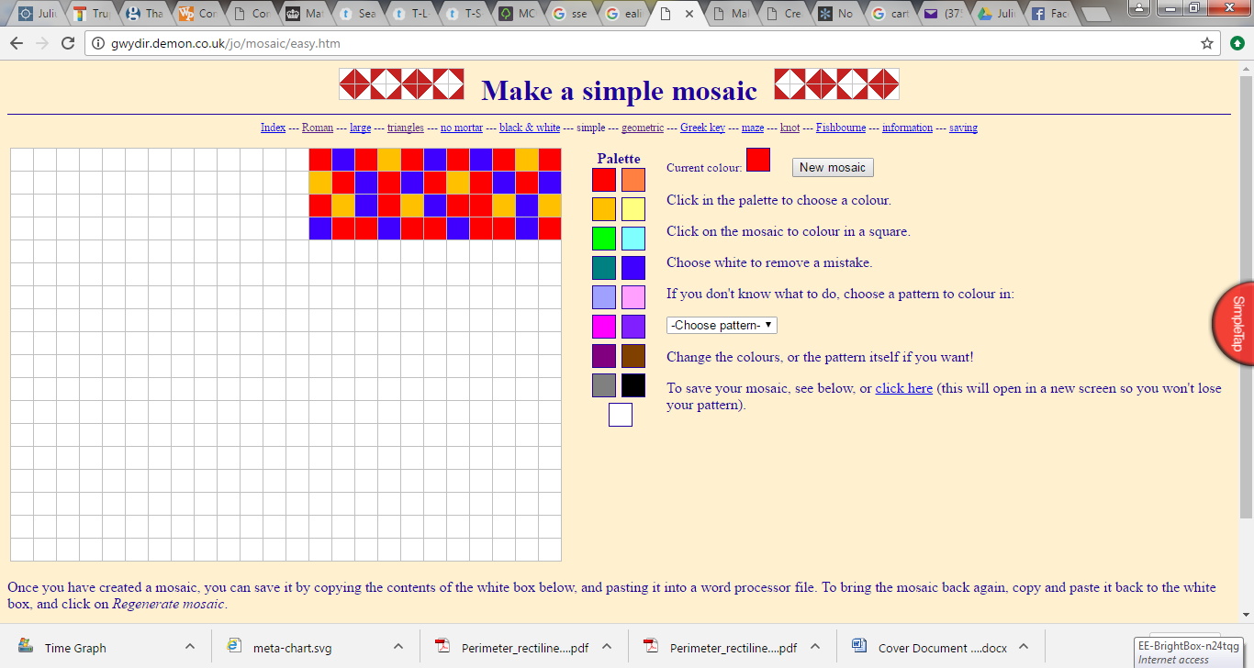Below are samples of Caesar’s new bathroom. Measure the area of each rectangular sample to the nearest centimetre². Use a ruler to measure the width and the length. The design that Caesar chooses will have to be converted into metres. Can you convert the area of each rectangle into meters²?

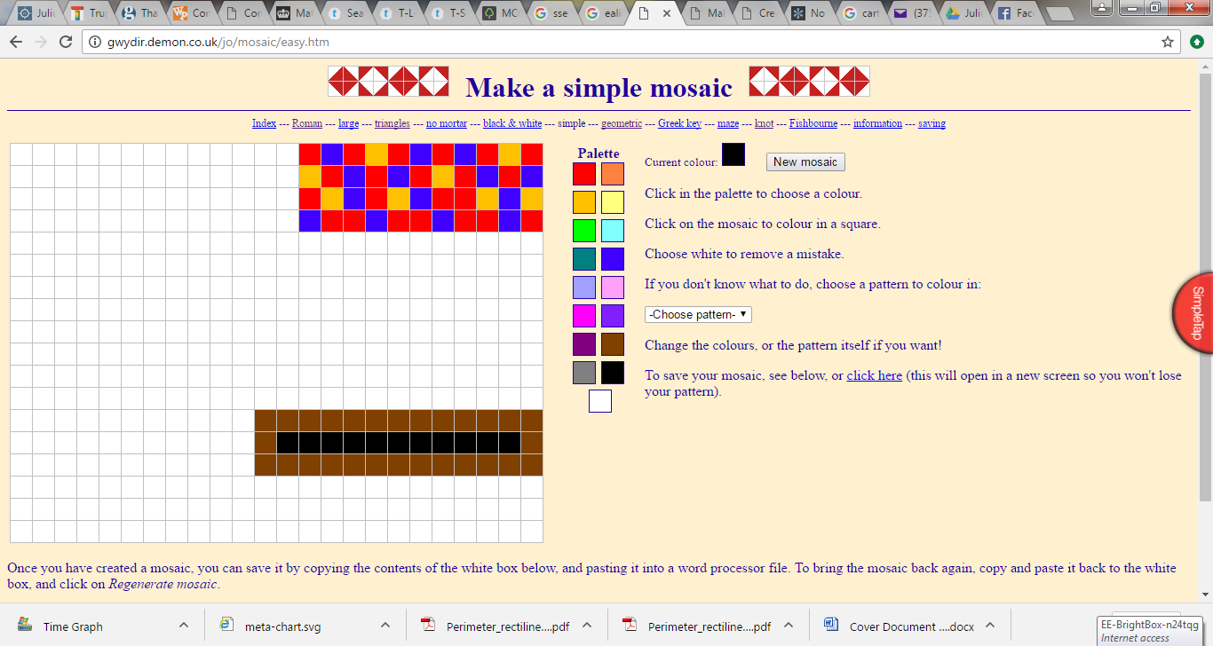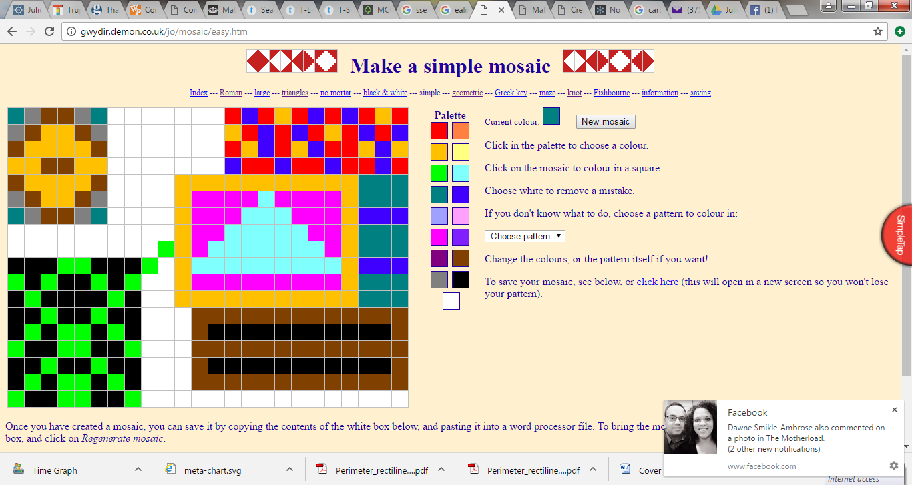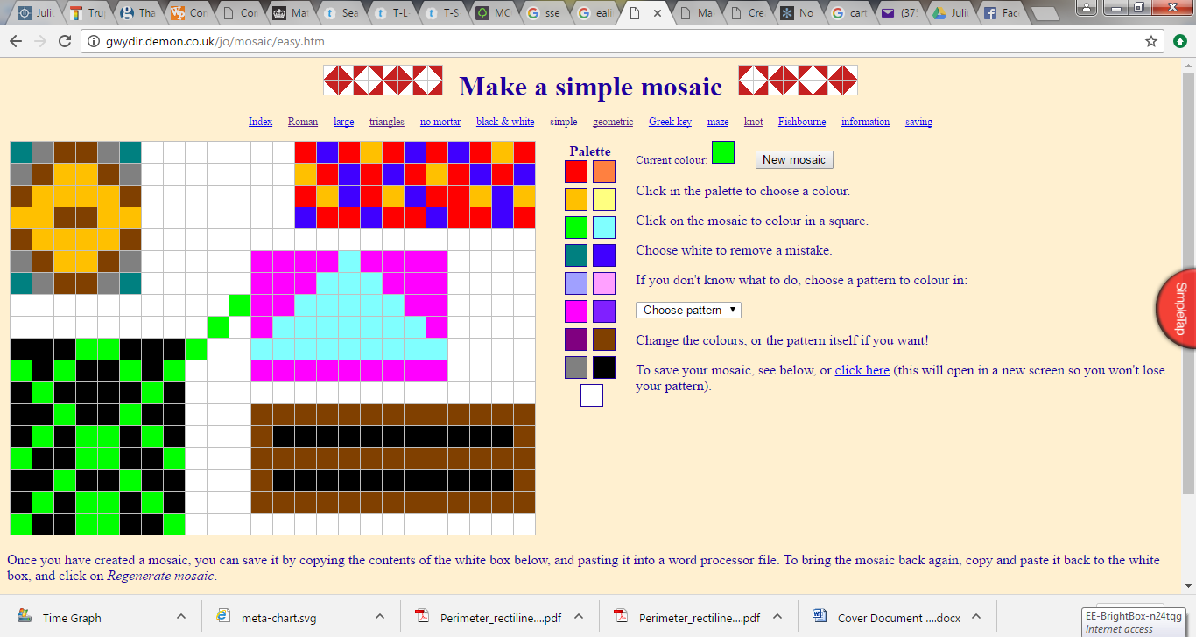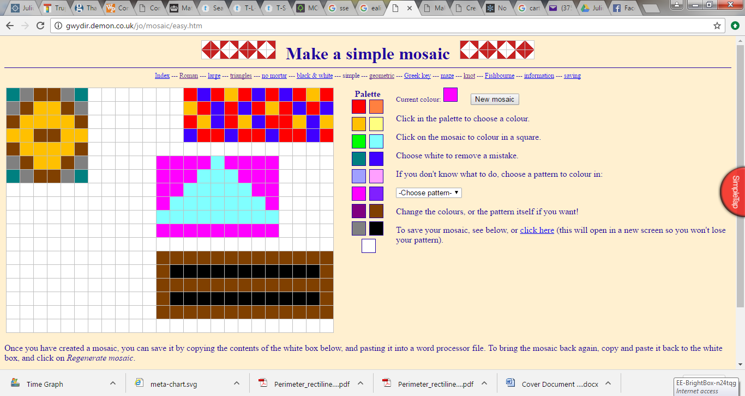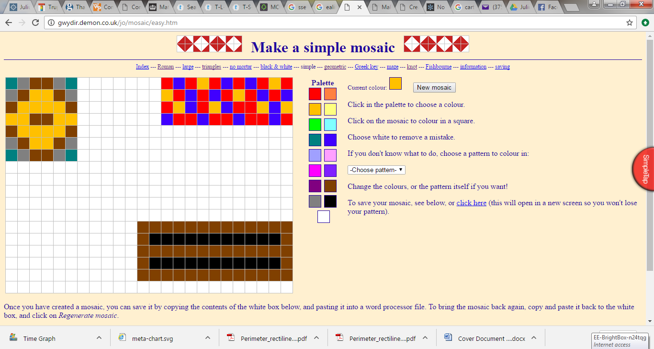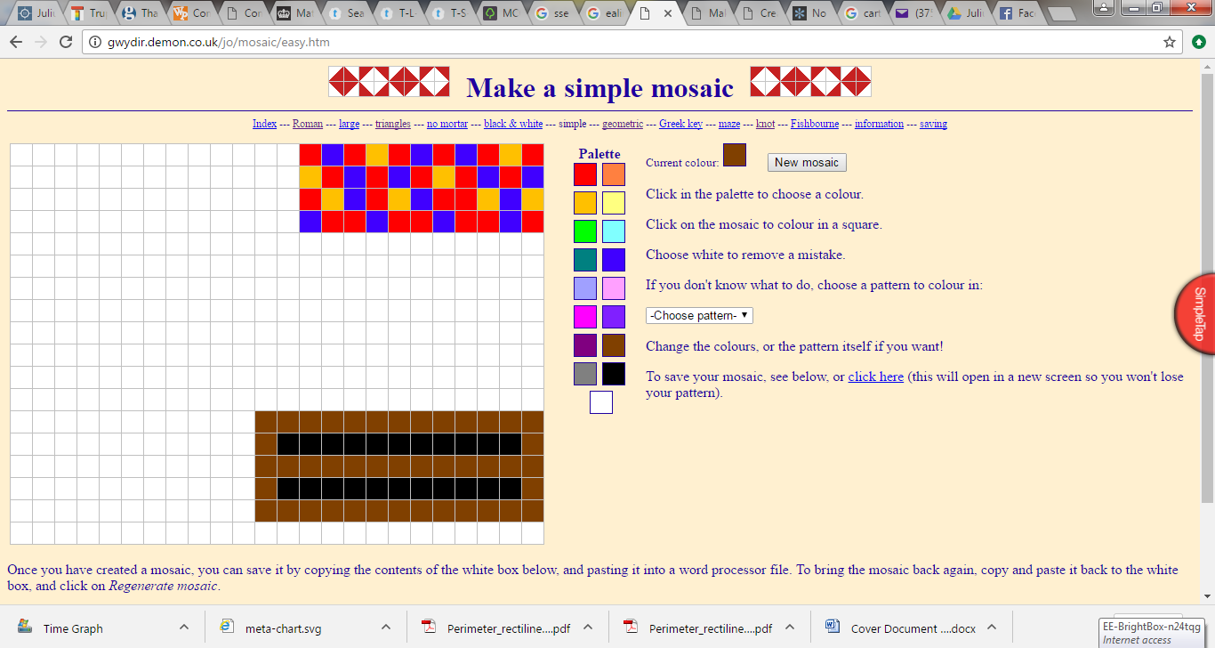

-The above rectangle measures 8.8cm in length and 2cm in width.

-I round 8.8cm to the nearest whole cm, which is 9cm.

-I work out the A by multiplying one number by the other 9x2 = 18cm²

- I convert it to meters by dividing by 100, 18 ÷ 100 = 0.18m²

- so the answers are: 18cm² and 0.18m²