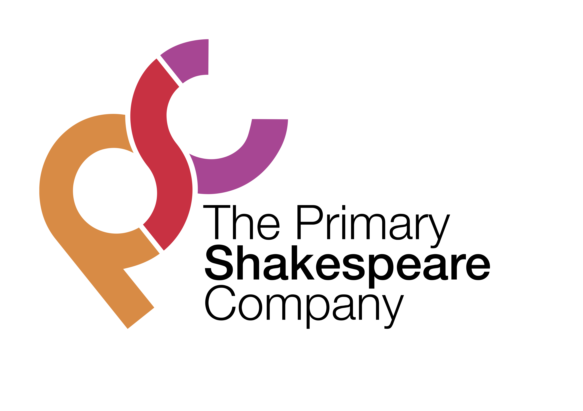

Lesson 5

LI: To edit and perform.
National Curriculum Links

Writing
- Proofread for spelling and punctuation errors

- Assess the effectiveness of their own and others’ writing and suggesting improvements

- Read their own writing aloud, to a group or the whole class, using appropriate intonation and controlling the tone and volume so that the meaning is clear.

Starter:
Before the lesson, highlight one word that each child has misspelt in their monologues. Children should work in pairs to help each other look up the word in a dictionary and then correct it.

Main Teaching:
Before the lesson, type up one child’s monologue so that it is visible on the interactive whiteboard for the whole class to see.

Read it out to the children and ask them to share the phrases and sentences that they really like, giving reasons for their choices. Highlight the phrases and sentences on the interactive whiteboard.

Now explain to the children that they are going to improve this monologue by editing it carefully.

Read the monologue out loud again. This time the children should put their hands on their head whenever they think they see a mistake (e.g. missing punctuation, a sentence which is too long, a spelling mistake).

Model correcting these mistakes with a green pen.

Once all the mistakes have been corrected, ask a child to read out the monologue. Ask the children how the writing is better. Why is it important that we use consistent punctuation in our writing?

Children now work in partners to edit their work. Partner A reads their work to Partner B. Both children look for mistakes and discuss how to correct them. Partner A holds the pen and makes any necessary corrections. Swap roles and repeat.

Performance
When they have finished editing, give children the chance to practise performing their monologues out loud.

Ask them to think about the expression they are using to show how Romeo is feeling.

Model performing with and without expression. Which performance is better and why?

Encourage children to perform their monologues to the class. You may like to record them to create a film to show parents and other classes.

