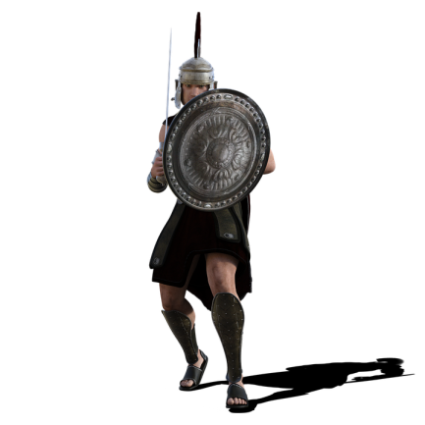

Caesar has lots of different divisions in the army. Reports of how many survived the battle are different from different sources. Help Caesar by finding the mean number of men left in each division



Write three similar ‘mean army’ problems for your partner…

Division 7

75, 78, 75, 71, 78, 25, 75, 29

Division 3

68, 71, 71, 84, 53, 62, 67

Division 9

72, 75, 59, 75, 59

Division 8

63, 69, 74, 56, 63

Division 6

75, 39, 75, 71, 79, 55, 75, 59

Division 5

21, 21, 19, 19

Division 4

18, 12, 10, 10, 25

Division 2

48 56 46

Division 1

46 53 70 59