Multiply the Ingredients for the Wedding Feast

In Act 4, Juliet tells her parents she will marry Paris. Lady Capulet is so excited and demands the servants plan a fabulous feast. They don’t have much time to prepare and need your help to work out the quantities of ingredients that they will need.

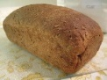For the bread:

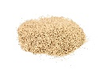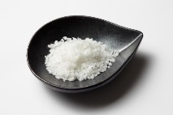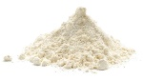

37 x 8g of salt =

31 x 2g of salt =

45 x 9g of flour =

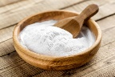

46 x 7ml of warm water =

38 x 6g of baking soda =

42 x 8ml of milk =



For the soup:

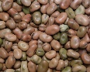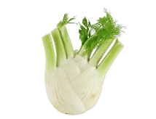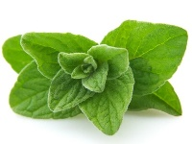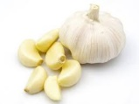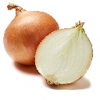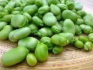

90 x 7g of fennel =

83 x 8g of oregano =

61 x 8g of garlic =

59 x 4g of onion =

65 x 6g of beans =

50 x 4g of fava beans =

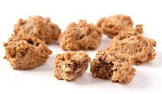

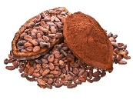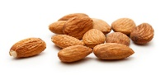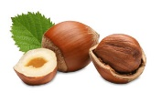For the bruttiboni (cake):

24 x 5g of cocoa =

21 x 4g of vanilla=

187 x 8g of sugar =

192 x 4g of almonds =

201 x 3g hazelnuts =

117 x 8 eggs =