Lesson 3  Act 2 Scene 1  Seasons in Turmoil | Dance/Movement  Choral Performance  Freeze Framing | L.O. To write a setting description  Success Criteria  Use of imagery  - Metaphor  - Personification  - Simile
Context:  In Shakespeare’s time, there had been some years that the weather had been abnormal. During 1594-1596, England experienced abnormal summers which were actually extremely wintry: wet and cold. Some areas suffered extreme flooding too. Harvests also failed during this period which led to famine.  Link this to the topic of climate change, and the effects of our actions on the planet’s eco-systems, which could lead on to a topical debate with your class. | Explain to the class that they will be creating a simple movement sequence which will explore the concept of increasing chaos/ turmoil in nature. In advance, select pieces of music which could represent the floods, droughts and other strange happenings which have occurred as a result of Oberon and Titania’s dispute: mixed-up seasons: frost in summer, flowers blooming in winter, air filled with disease, crops lie rotting in the fields, animals dying, villages covered with mud (see Titania’s monologue in resource 3A below).  Children to form groups of four. Position children in a diamond shape, all facing the same direction. Identify a ‘leader’ within each diamond formation. The leader starts by making slow, gentle movements/gestures with their body. The rest of the group mirror these actions. When the leader is ready to move on, they turn their body 90 degrees to the left or right. The next person automatically becomes the leader (as the rest of the group are behind and can see them). The new leader adopts a new sequence of movements which the group again copy, as accurately as possible.  When the group are ready, start again and this time experiment with different moods, according to different soundtracks/musical accompaniments.  When each child has ‘led’ the group, a different soundtrack can be selected to express a particular weather or example of chaos (start with a gentle piece of music, which can then move into angrier/ more chaotic sounding pieces).  Extension- other children can read aloud Titania’s monologue as the group perform their movement sequence.  Choral Performance:  Arrange half the class into a semi-circle and explain that pairs of children will read sections of Titania’s monologue in turn (see resource 3A below). The remaining half of the children will then stand in two lines opposite each other. Ask them to experiment with freeze-framing actions/gestures which represent the examples of how her quarrel with Oberon has affected nature. As the monologue is read aloud pairs take it in turns to freeze frame their movements. | Introduce the idea of naughty ‘imps’. Explain that this can help pupils with remembering how writers create special visual effects by playing with words (this is figurative language). Imps is an acronym for:  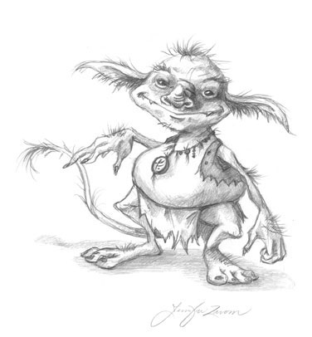  I=IMAGERY  M=Metaphor  P=Personification  S=Simile  Pull out the examples of imagery from Titania’s monologue (see highlighted exceprts) and colour code, focussing on the differences between use of metaphor, personfication and simile.  Then using images or photos of floods, drought, or any other extreme weather condition, model to children how to create effective figurative language through the use of metaphor, personification and simile. e.g.  The trees flinched and shivered in the freezing rain.  Melting chips of ice hammered down from the angry clouds above.  The dancing hail hung in a dense cloud, and drove down the road like thick smoke.  A damp, yellow fog hung over the park and twisted the trees into monstrous shapes.  The fog crept up on the house like a ghostly serpent, slid along the window, flicked its tongue into the corners of the house, waited a moment and then slipped back along the path.  If required, provide examples for the pupils to refer to.  The Descriptosaurus by Alison Wilcox (published by David Fulton, Routledge) provides a wealth of examples, as does Chambers’ Eyes like Butterflies’, by Terence Hodgson.  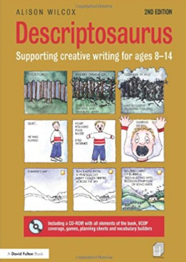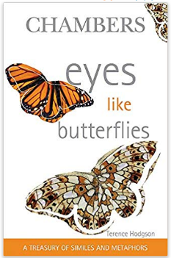  These examples of figurative language can then be used as a starting point for a setting description.

Lesson 3A

I=IMAGERY
M=Metaphor
P=Personification
S=Simile

Titania’s monologue

…….the winds, piping to us in vain,
As in revenge, have sucked up from the sea
Contagious fogs, which falling in the land
Have every pelting river made so proud
That they have overborne their continents.
The ox hath therefore stretched his yoke in vain,
The ploughman lost his sweat, and the green corn
Hath rotted ere his youth attained a beard.
The fold stands empty in the drownèd field,
And crows are fatted with the murrain flock.
The nine-men’s-morris is filled up with mud,
And the quaint mazes in the wanton green
For lack of tread are undistinguishable.
The human mortals want their winter here.
No night is now with hymn or carol blessed.
Therefore the moon, the governess of floods,
Pale in her anger, washes all the air,
That rheumatic diseases do abound.
And thorough this distemperature we see
The seasons alter: hoary-headed frosts
Fall in the fresh lap of the crimson rose,
And on old Hiems' thin and icy crown
An odorous chaplet of sweet summer buds
Is, as in mockery, set. The spring, the summer,
The childing autumn, angry winter change
Their wonted liveries, and the mazèd world,
By their increase, now knows not which is which.
And this same progeny of evils comes
From our debate, from our dissension.
We are their parents and original.

