Athens Olympics
1896 Summer Olympics
1906 Intercalated Games
2004 Summer Olympics
- Many years were there between the 1896 and the 2004 Olympics?

- The first Olympics was held in Athens, Greece, from 6 to 15 April 1896. The 2004 Summer Olympic Games ran from 13 to 29 August 2004. Which games were longer and by how many days?
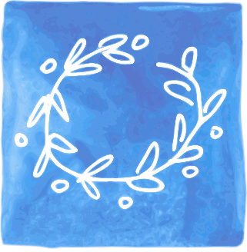
- Here is the medal table for the top 15 counties from the 2004 games.
- Fill in the blanks
- Total how many gold, silver and bronze medals were given out to the top 15 counties?
1906 Gold = Silver = Bronze =
2004 Gold = Silver = Bronze =
1906 2004

6. Ask two of your own questions about the tables.

- How many medals did the top 5 countries receive altogether?
- Look at this table. How many medals were given out at the 2004 games altogether?

