Prospero’s House – Area & Perimeter

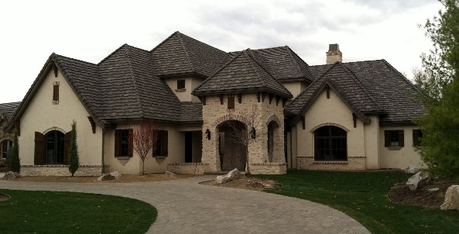

Help measure the different rooms and spaces within my house

[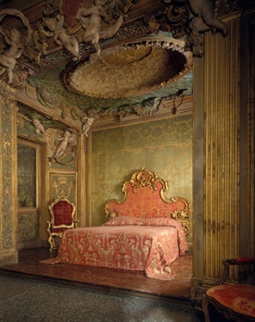](https://www.google.co.uk/url?sa=i&rct=j&q=&esrc=s&source=images&cd=&cad=rja&uact=8&ved=0ahUKEwi27o6PhsjYAhVaOMAKHfzGAcUQjRwIBw&url=https://www.metmuseum.org/toah/ht/09/eustn.html&psig=AOvVaw3ha8JuhB9Ps6ij3Tsb3ter&ust=1515489939824480)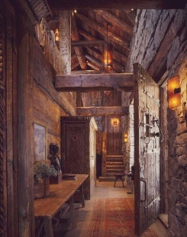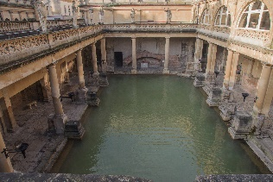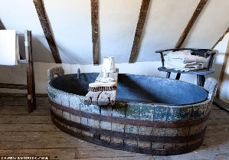 [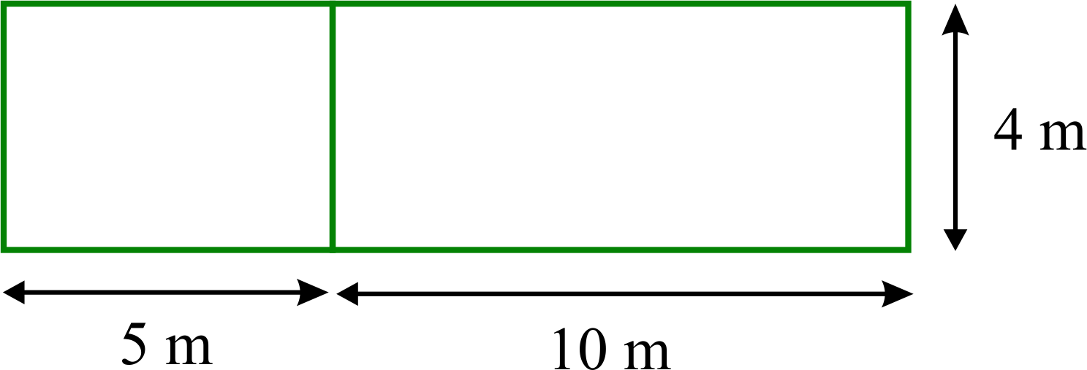](https://www.google.co.uk/url?sa=i&rct=j&q=&esrc=s&source=images&cd=&cad=rja&uact=8&ved=0ahUKEwiI8r-wj8jYAhUMJ8AKHRHLBKAQjRwIBw&url=https://www.homeschoolmath.net/teaching/g/area-perimeter.php&psig=AOvVaw1oR45KVRzxQFvUcWxjYBc-&ust=1515491627831582)[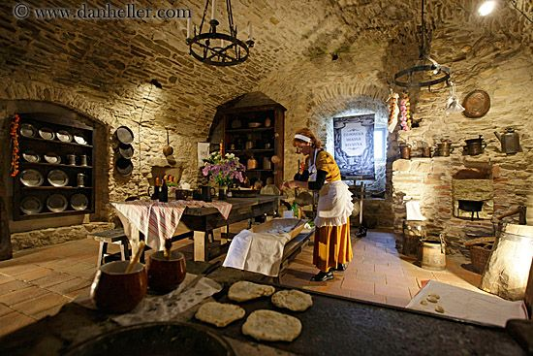](https://www.google.co.uk/url?sa=i&rct=j&q=&esrc=s&source=images&cd=&cad=rja&uact=8&ved=0ahUKEwi54cPDicjYAhXlJ8AKHZDsAnMQjRwIBw&url=https://www.pinterest.com/pin/844493650975513/&psig=AOvVaw3uypFv0CYYNgeqBfxg5dwa&ust=1515490239990160)**[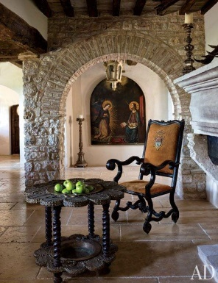](http://www.architecturaldigest.com/decor/2013-11/martyn-lawrence-bullard-evgeny-lebedev-domenico-minchilli-umbria-italy-castle-slideshow_slideshow_After--Dining-Room_12)**[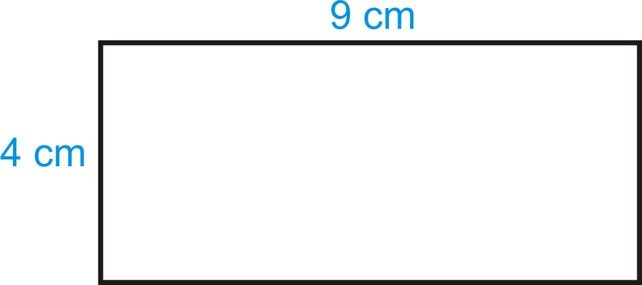](https://www.google.co.uk/url?sa=i&rct=j&q=&esrc=s&source=images&cd=&cad=rja&uact=8&ved=0ahUKEwj4gqrIiMjYAhXqIMAKHavpA_8QjRwIBw&url=https://www.ck12.org/geometry/square-and-rectangle-area-and-perimeter/lesson/Area-and-Perimeter-of-Rectangles-GEOM/&psig=AOvVaw0y2ueNPiV-duJFKLDgbN68&ust=1515490590997674)

4m

9m

The hallway is 13m long but only 2m wide. What is the area and the perimeter?

The room is 3m by 4m. Using a ruler draw the room. 1m = 1cm.

Challenges:

* Draw the living room, which is triangular in shape. Each side measures 8m. Use a ruler, 1m = 1cm.
* Prospero’s office, where he practises his magic has an area of 12m2 . It could be square or rectangular. Draw all of the possibilities…

1. hallway

The pool is rectangular. The length is 19m and the width is 23m. What is the perimeter?

1. swimming pool

4. bathroom

1. Kitchen

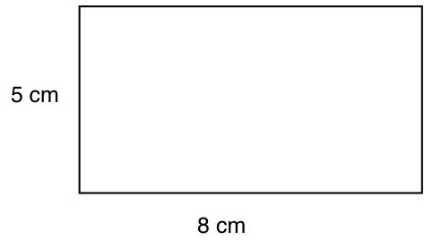

1. entrance way
2. bedroom