Fairies
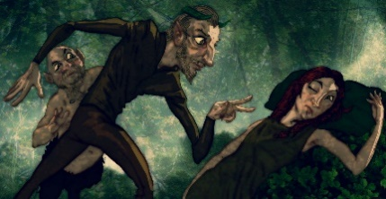
Puck - Oberon’s jester, a mischievous fairy who delights in playing pranks on mortals.
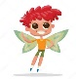
Oberon - The king of the fairies
Titania - The beautiful queen of the fairies
Peaselblossom , Moth, Cobweb, Mustardseed – Fairy servants to Titania.

If the number is written in numerals, convert it to words and if the number is written, convert it into numerals. Example: Titania's asks for 997 ‘apricocks’. Answer: nine hundred and ninety-seven

- Oberon squeezes forty-five millilitres of liquid from an enchanted flower onto Titania’s eyelids.

- Puck casts a spell that exchanges Bottom’s human head for that of a donkey, the spell takes three hundred and fifty-nine minutes to work properly.

- Titania's asks for two hundred and fourty dewberries to be picked.

- Titania then decides she also wants one hundred and eight green figs ninety four mulberries.
Titania needs several items for a spell:
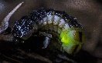
- 435 fiery glow-worm's eyes
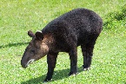
- 911 night-tapers

- 787 honey-bags stolen from the humble-bees
- One hundred and sixty one plucked wings from painted butterflies
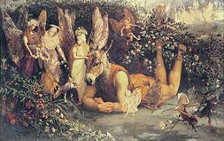
Write 4 of your own sentences that include numbers written as words for a partner to convert.

You might find inspiration in this description of Titania…
"A bank where the wild thyme blows,
Where ox-lips and the nodding violet grows;
Quite over-canopied with luscious woodbine,
With swee musk-roses, and with eglantine;
There sleeps Titania, sometimes of the night,
Lull'd in these flowers with dances and delight;
And there the snake throws her enamell'd skin,
Weed wide enough to wrap a fairy in."

