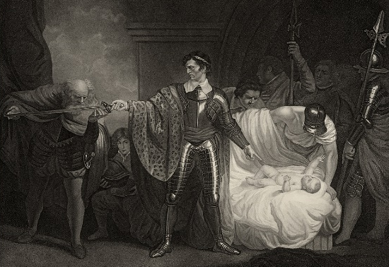
What’s a Name Worth?
Try your own name…
Paulina
Camilla
Florizel
Polixenes
Perdita
Hermione
Leontes (example)
l = 501
e = 119
o = 505
n = 366
t = 209
e = 119
s = 325
2144
Add all of the letters in each name together to work out whose name is worth the most!
a = 124
b = 302
c = 198
d = 234
e = 119
f = 456
g = 237
h = 789
i = 104
j = 247
k = 309
l = 501
m = 992
n = 366
o = 505
p = 405
q = 113
r = 738
s = 325
t = 209
u = 546
v = 384
w = 710
x = 382
y = 254
z = 315

Whose name is worth the most?

