The Capulet Property

In Act 2, Scene 1, Romeo is still at the Capulet property. Help measure the perimeter of the different rooms so it’s easier for Romeo to find his way around when dark...

1. The Capulet hallway
2. Juliet’s bedroom

[](https://www.google.co.uk/url?sa=i&rct=j&q=&esrc=s&source=images&cd=&cad=rja&uact=8&ved=0ahUKEwj4gqrIiMjYAhXqIMAKHavpA_8QjRwIBw&url=https://www.ck12.org/geometry/square-and-rectangle-area-and-perimeter/lesson/Area-and-Perimeter-of-Rectangles-GEOM/&psig=AOvVaw0y2ueNPiV-duJFKLDgbN68&ust=1515490590997674)[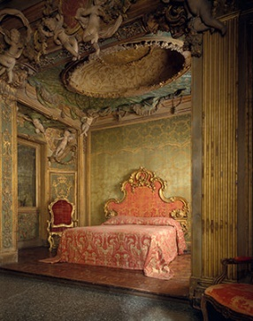](https://www.google.co.uk/url?sa=i&rct=j&q=&esrc=s&source=images&cd=&cad=rja&uact=8&ved=0ahUKEwi27o6PhsjYAhVaOMAKHfzGAcUQjRwIBw&url=https://www.metmuseum.org/toah/ht/09/eustn.html&psig=AOvVaw3ha8JuhB9Ps6ij3Tsb3ter&ust=1515489939824480)

9m

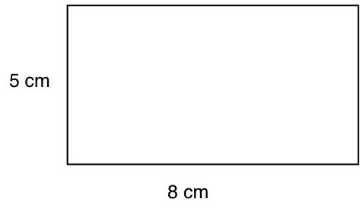

**[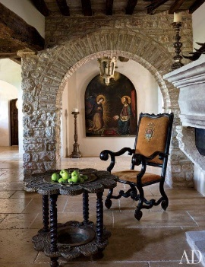](http://www.architecturaldigest.com/decor/2013-11/martyn-lawrence-bullard-evgeny-lebedev-domenico-minchilli-umbria-italy-castle-slideshow_slideshow_After--Dining-Room_12)**

4m

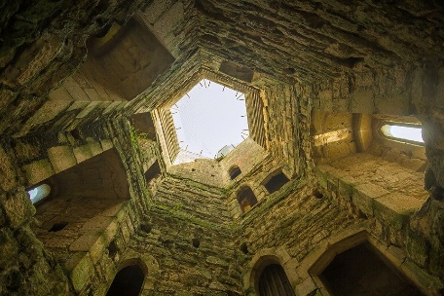[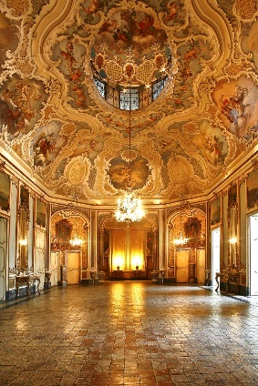](https://www.google.co.uk/url?sa=i&rct=j&q=&esrc=s&source=images&cd=&cad=rja&uact=8&ved=0ahUKEwiX7p3U_sfYAhXLKsAKHTHeAecQjRwIBw&url=https://www.pinterest.com/keepstrying/castles-and-palaces/&psig=AOvVaw2Bf3P2MvD3z_Sm9ECHnsRO&ust=1515487919920156)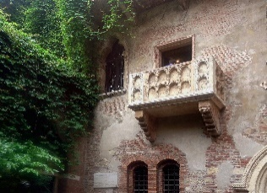 [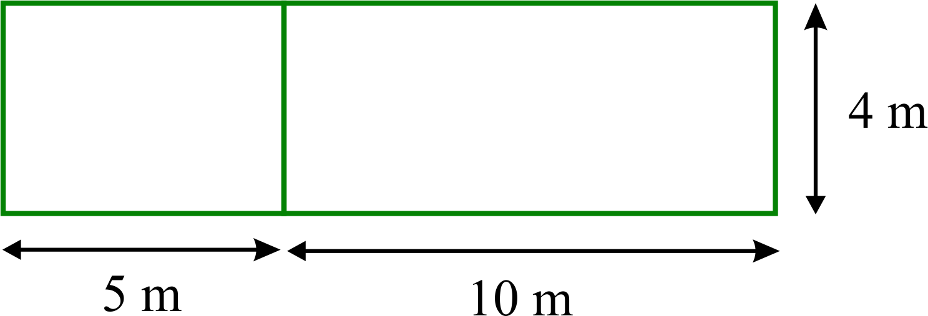](https://www.google.co.uk/url?sa=i&rct=j&q=&esrc=s&source=images&cd=&cad=rja&uact=8&ved=0ahUKEwiI8r-wj8jYAhUMJ8AKHRHLBKAQjRwIBw&url=https://www.homeschoolmath.net/teaching/g/area-perimeter.php&psig=AOvVaw1oR45KVRzxQFvUcWxjYBc-&ust=1515491627831582)[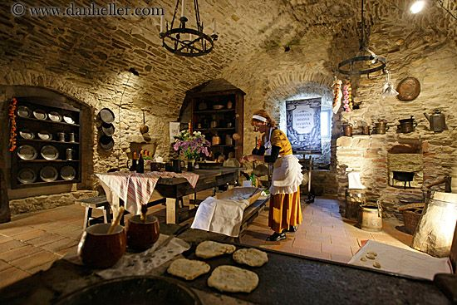](https://www.google.co.uk/url?sa=i&rct=j&q=&esrc=s&source=images&cd=&cad=rja&uact=8&ved=0ahUKEwi54cPDicjYAhXlJ8AKHZDsAnMQjRwIBw&url=https://www.pinterest.com/pin/844493650975513/&psig=AOvVaw3uypFv0CYYNgeqBfxg5dwa&ust=1515490239990160)

One side is 3m.

1. Challenge – draw a floorplan of the Montague Property and label each room with its perimeter.

1cm = 1m

Now, swap with a partner and check each other’s work.

1. The hexagonal tower

The ballroom is rectangular. The length is 19m and the width is 23m. What is the perimeter?

1. ballroom

Measures 96cm in width and 156cm in length.

4. Juliet’s balcony

1. Kitchen