Athens Palace Extension

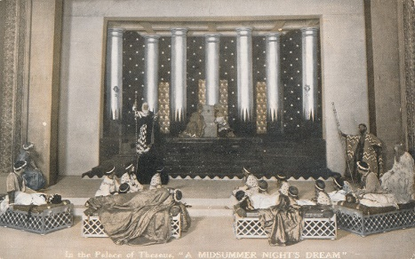Theseus has decided that he wants a larger palace so he decides to build an extension. Help the builders divide the bags of sand correctly to the place where each new room will be. [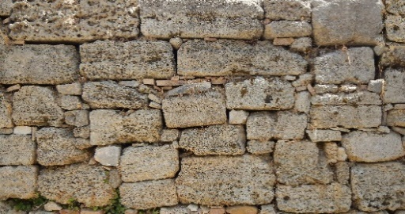](https://www.google.co.uk/url?sa=i&rct=j&q=&esrc=s&source=images&cd=&cad=rja&uact=8&ved=0ahUKEwi3-PaI-d7YAhURUlAKHX-UAMgQjRwIBw&url=http://www.lughertexture.com/stone-plates-and-ornaments-textures-download/medieval-stone-blocks-texture&psig=AOvVaw178Sd6zYAa8OT-S-UG427s&ust=1516276711975553)[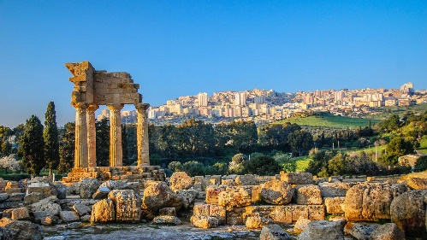](https://www.google.co.uk/url?sa=i&rct=j&q=&esrc=s&source=images&cd=&cad=rja&uact=8&ved=0ahUKEwif9cjh_d7YAhVCDMAKHWdIAT4QjRwIBw&url=http://www.kuoni.co.uk/italy/sicily/hotels&psig=AOvVaw3EMuccxUSNcLk2QDQ7GNyt&ust=1516277956235654)

1. 0.8 bag into 10 rooms.
2. 21.9 bags into 100 rooms.
3. 21.9 bags into 10 rooms.
4. 1.5 bags into 10 rooms.
5. 689 bags into 100 rooms.
6. 19 bags into 10 rooms.
7. 76 bags into 100 rooms.
8. 92 bags into 100 rooms.
9. 333 bags into 100 rooms.
10. 10 bags into 100 rooms.
11. 35 bags into 100 rooms.
12. 56 bags into 10 rooms.
13. 4 bags into 10 rooms.

[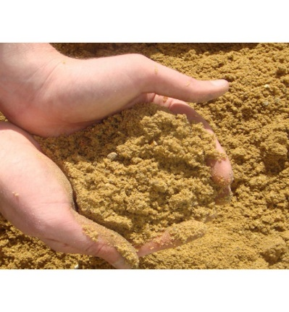](https://www.google.co.uk/url?sa=i&rct=j&q=&esrc=s&source=images&cd=&cad=rja&uact=8&ved=0ahUKEwiSiabthN_YAhWiD8AKHaDzCSoQjRwIBw&url=https://www.springbridge.co.uk/sharp-sand-small-bag&psig=AOvVaw2bARsk0XPf9tIsi0lTAHf0&ust=1516279858384210)