[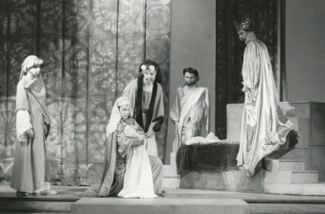](https://www.google.co.uk/url?sa=i&rct=j&q=&esrc=s&source=images&cd=&cad=rja&uact=8&ved=0ahUKEwichJz268bYAhWnLMAKHeV7B_YQjRwIBw&url=http://www.sohamgrammar.org.uk/winters_tale.htm&psig=AOvVaw2MGuPf14A7ueym1IQsTxkV&ust=1515448522200349)King Leontes’ Sicilian court

[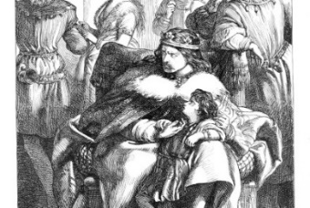](https://www.google.co.uk/url?sa=i&rct=j&q=&esrc=s&source=images&cd=&cad=rja&uact=8&ved=0ahUKEwji64LHgMjYAhWLLMAKHdp7DX8QjRwIBw&url=https://shakespeareillustration.org/category/characters/male/leontes/&psig=AOvVaw1FbBEIcLcxi7ObGvjL6A0M&ust=1515488406755324)

Help measure the different rooms in Leontes’ castle.

1. Leontes’ bedroom

17m

1. Gatehouse

[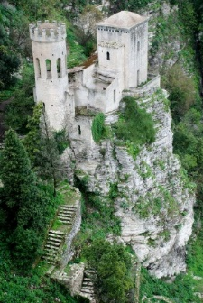](https://www.google.co.uk/url?sa=i&rct=j&q=&esrc=s&source=images&cd=&cad=rja&uact=8&ved=0ahUKEwj6sdmWi8jYAhVHCMAKHVV0BW0QjRwIBw&url=https://www.pinterest.co.uk/pin/221872719114520260/&psig=AOvVaw21FFGG0QbsHIq3iT8arhSr&ust=1515491288430340)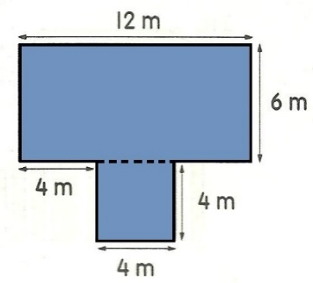[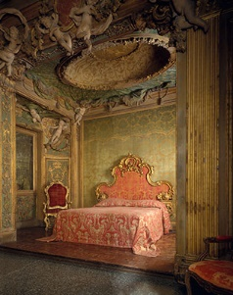](https://www.google.co.uk/url?sa=i&rct=j&q=&esrc=s&source=images&cd=&cad=rja&uact=8&ved=0ahUKEwi27o6PhsjYAhVaOMAKHfzGAcUQjRwIBw&url=https://www.metmuseum.org/toah/ht/09/eustn.html&psig=AOvVaw3ha8JuhB9Ps6ij3Tsb3ter&ust=1515489939824480)

5m

gatehouse

A =

P =

bedroom

A =

P =

10m

1. Kitchen

[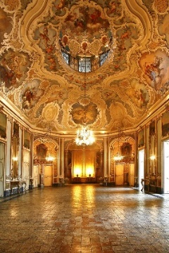](https://www.google.co.uk/url?sa=i&rct=j&q=&esrc=s&source=images&cd=&cad=rja&uact=8&ved=0ahUKEwiX7p3U_sfYAhXLKsAKHTHeAecQjRwIBw&url=https://www.pinterest.com/keepstrying/castles-and-palaces/&psig=AOvVaw2Bf3P2MvD3z_Sm9ECHnsRO&ust=1515487919920156)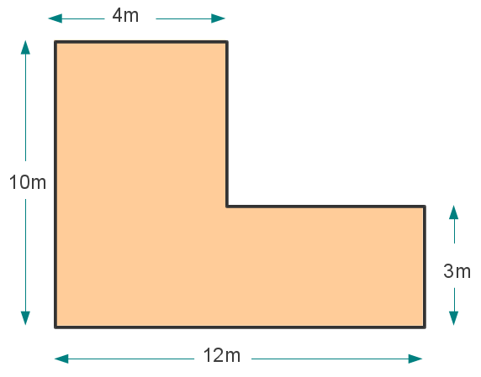[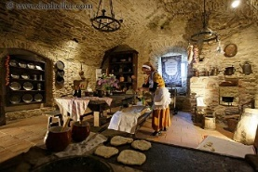](https://www.google.co.uk/url?sa=i&rct=j&q=&esrc=s&source=images&cd=&cad=rja&uact=8&ved=0ahUKEwi54cPDicjYAhXlJ8AKHZDsAnMQjRwIBw&url=https://www.pinterest.com/pin/844493650975513/&psig=AOvVaw3uypFv0CYYNgeqBfxg5dwa&ust=1515490239990160)

ballroom

A =

P =

1. Ballroom

kitchen

A =

P =

12m

Can you draw 3 rooms that have the same area but a different perimeter?

What do you notice about the area and perimeter of the rooms above?