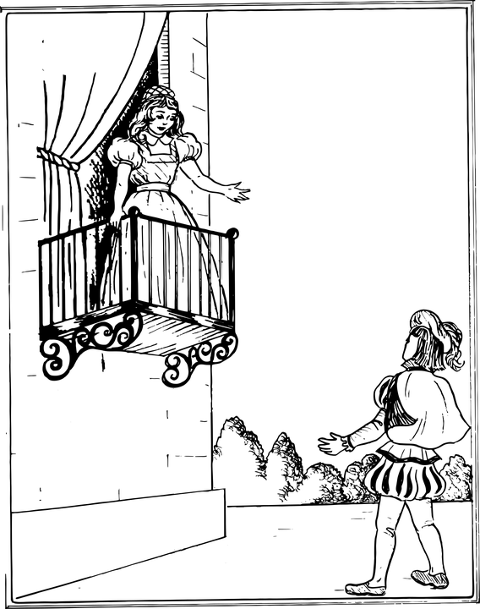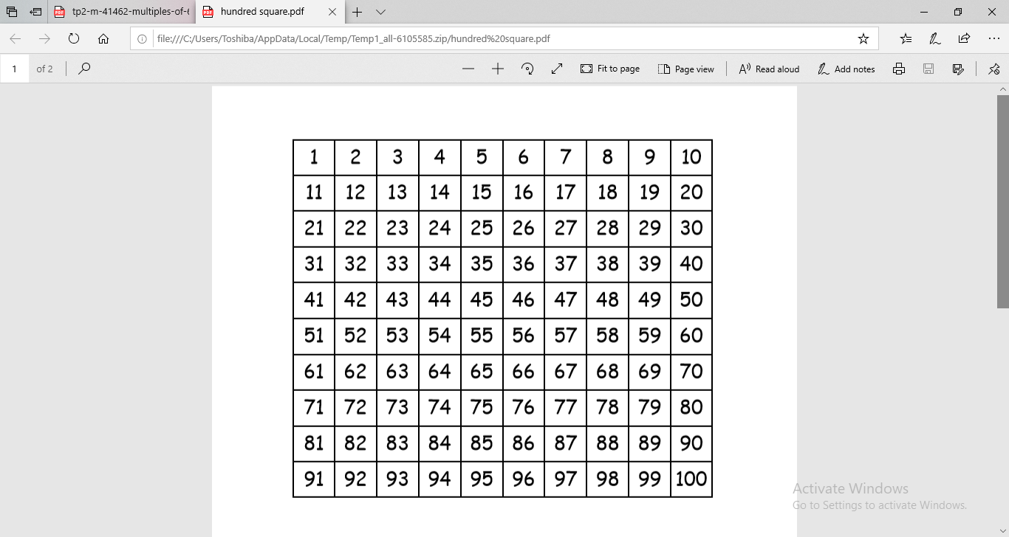 Help Romeo save Juliet by cracking the code…

The answer is:

1. Chose a colour for multiples of 4 and a different colour for multiples of 8.
2. With the selected colour, draw a box around the inside of any multiples of 4

and draw a cross through any multiples of 8.

1. Below, write all numbers that are a multiple of 4 and 8 in order.

.......... .......... .......... .......... .......... .......... .......... .......... .......... .......... .......... ..........

1. Circle the two numbers in the middle of the row above. Add them together.
2. Half the number.
3. Multiply it by 3.
4. Double it.
5. Add 49 to it.

Note down any patterns that you can see:

Key

Multiples of 4

Multiples of 8