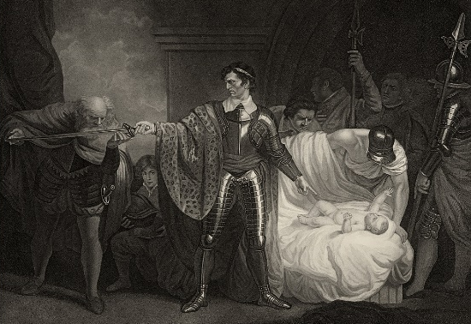
What’s a Name Worth?
Try your own name…
Paulina
Camilla
Florizel
Polixenes
Perdita
Hermione
Leontes (example)
l = 5018
e = 1196
o = 5051
n = 3663
t = 2099
e = 1196
s = 3252
21,475
Add all of the letters in each name together to work out whose name is worth the most!
a = 1242
b = 3023
c = 1981
d = 2340
e = 1196
f = 4568
g = 2379
h = 7892
i = 1043
j = 2475
k = 3096
l = 5018
m = 7920
n = 3663
o = 5051
p = 4059
q = 1135
r = 7386
s = 3252
t = 2099
u = 5463
v = 3847
w = 7109
x = 3822
y = 2544
z = 3158

Whose name is worth the most?

