Multiply the Ingredients for the Wedding Banquet
At the wedding, Prospero introduces the masque. In the sixteenth and seventeenth centuries, masques were popular forms of entertainment in England. Masques featured masked actors performing allegorical, often highly ritualized stories drawn from mythology and folklore. They then sat down to have a banquet. They don’t have much time to prepare and need your help to work out the quantities of ingredients that they will need.
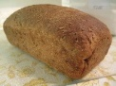
For the bread:
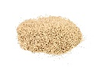
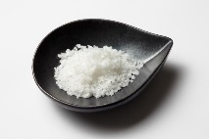
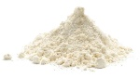
327 x 8g of salt =
311 x 2g of salt =
415 x 9g of flour =
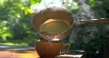
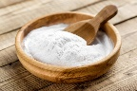
146 x 47ml of warm water =
381 x 16g of baking soda =
421 x 18ml of milk =

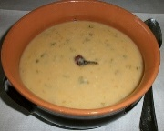
For the Maccu Soup:

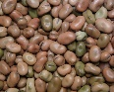
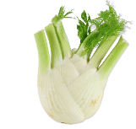
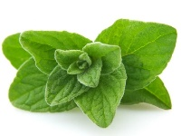
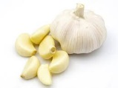
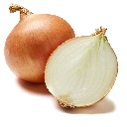
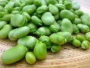
901 x 17g of fennel =
831 x 28g of oregano =
612 x 18g of garlic =
591 x 42g of onion =
651 x 61g of beans =
508 x 54g of fava beans =

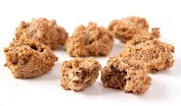
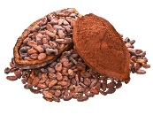
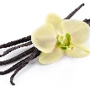
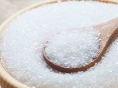
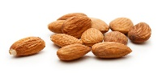
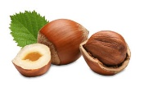
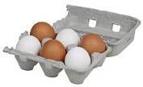
For the Bruttiboni:
2421 x 55g of cocoa =
2160 x 94g of vanilla=
3187 x 38g of sugar =
1923 x 64g of almonds =
2012 x 73g hazelnuts =
1171 x 28 eggs =

