Lesson 2  Act 2 Scene 1  The Fairy King and Queen | Character Sculpting | L.O. To write a third person narrative  Success criteria:  Use of ‘show not tell’ to describe the characters’ thoughts and feelings.
Warm up: Numbered Bodies  Start warming up the class using the same activity in lesson 1 i.e. calling out a word to describe how pupils ‘move’ around the space.  Variation: then call a number and a body part e.g. ‘Four knees!’. Children then assemble as quickly as possible in a group with the correct number of body parts touching. This can be played in multiple rounds as an elimination game. | Context: Oberon wants the Indian changeling boy to be his page. The fairy King and Queen are arguing.  Explain to the class that in this lesson they will be exploring the physical characterisation of the fairies.  Start by assembling the class in to groups of three. Children will work together to create physical sculptures of the fairies, using their bodies.  Allocate a fairy character to a group, i.e. one of:  Titania, Oberon, Puck, Cobweb, Peaseblossom, Mustardseed, Moth or Fairy  Two pupils should ‘sculpt’ the third pupil into a pose that shows their fairy character’s personality (or how they imagine this fairy to act/behave). These sculptures can be brought to life in a dumb show, using mime to explore the start of Act 2 Scene 1. Emphasise the need for them as actors to SHOW (rather than TELL – see writing task) the fairy’s thoughts/feelings and personalities through their body movements and facial expressions  Then, encourage the pupils to think about how their fairy would introduce themselves. The group will select a gesture that they will perform as they say their name. e.g. Oberon might step forward, and bellow his name in a powerful voice. Cobweb may flounce or float side to side, giggling and whispering her name.  Using resource 2A (script) Titania and Oberon enter the scene with their servant fairies.  Plan: what will the fairies do on stage? How will they move/behave?  Act out the scene, exploring further the use of physical movement, gestures, voice and facial expressions | This drama activity leads on to the pupils composing a narrative scene, written in the third person.  This will need to be modelled to the children.  Start with ‘telling’ e.g. Oberon was angry.  Generate ideas, referring back to the drama, which will show Oberon’s anger.  e.g. Oberon stomped towards Titania, his eyes flashing. ‘Ill met by moonlight’ he snarled.  Titania’s gaze locked onto him. With a steely glint in her eyes she strode forwards,  ‘What, are you jealous Oberon?’ she hissed.  ‘Fairies, skip hence!’.  Discuss how the words in bold enable the reader to understand Titania and Oberon’s feelings in this scene.  If required, provide examples for the pupils to refer to.  The Descriptosaurus by Alison Wilcox (published by David Fulton, Routledge) provides a wealth of examples, and includes a CD Rom with PDf copies that can be printed and distributed very conveniently.  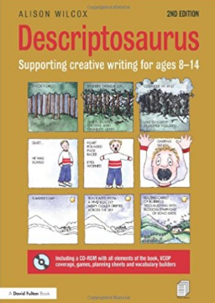
LESSON 2A

Act 2 Scene 1

Explore the way different directors have portrayed the relationship between Oberon and Titania. What do these images suggest about the power dynamics between these two?

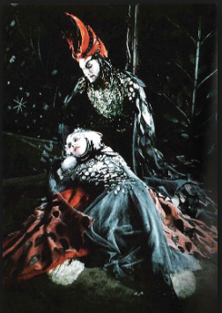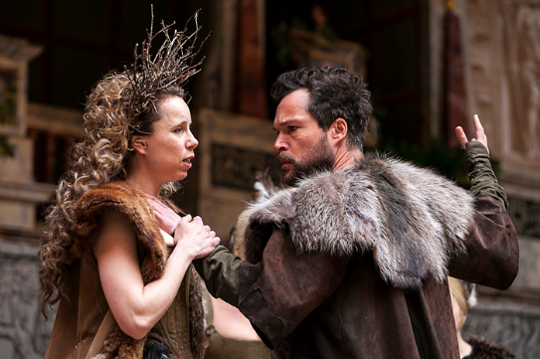

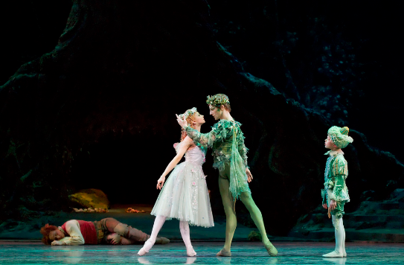
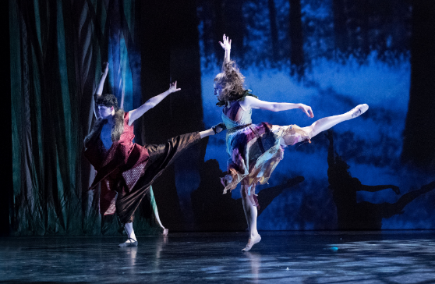

Lesson 2B

Act 2 Scene 1
A wood near Athens.

Enter, from opposite sides, a Fairy and PUCK

PUCK

How now spirit, whither wander you?

FAIRY

Over hill, over dale,
Thorough bush, thorough brier,
Over park, over pale
Thorough flood, thorough fire,
I do wander everywhere

PUCK

The king doth keep his revels here to-night:
Take heed the queen come not within his sight,
A lovely boy, stolen from an Indian king,
She never had so sweet a changeling,
And jealous Oberon would have the child
Knight of his train, to trace the forests wild.
But room fairy! Here comes Oberon!

FAIRY

And here my mistress. Would that he were gone!

Enter OBERON, with his train; and TITANIA with hers

OBERON

Ill met by moonlight, proud Titania

TITANIA
What, jealous Oberon? Fairies, skip hence.

OBERON

Why should Titania cross her Oberon?
I do but beg a little changeling boy
To be my henchman

TITANIA

Not for thy fairy kingdom! Fairies, away.
We shall chide downright, if I longer stay.

Exit TITANIA with her train

Source: RSC, Dream Team 2016, ‘Half hour edit’ script

