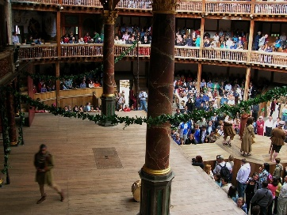
Facts about Shakespeare

- People who stand to watch the play at Shakespeare’s Globe sometimes faint, especially in warm weather. The play with the most fainting people so far is the violent and gory Titus Andronicus – there were XV at one performance.

- We celebrate Shakepeare’s birthday on XXIII April.

- He was baptised on XXVI April.

- There are more than LXXX variations recorded for the spelling of Shakespeare’s name. Examples of how Shakespeare spelt his name, include: “Willm Shaksp,” “William Shakespe,” and “Wm Shakspe”.

- Shakespeare was LII years old when he died.

- He wrote approximately XXXIX plays.

- At the age of XVIII, he married 26 year old Anne Hathaway.

- VI months after the marriage Anne gave birth to a daughter.

- Hamnet, Shakespeare’s son died of unknown causes at the age of XI.

- Shakespeare's Father, John was a money lender! He was accused in the Exchequer Court of Usury for lending money at the inflated rate of XX% and XXV% Interest!

- Challenge - The builders of The Globe had to measure more than M oak trees to build Shakespeare’s Globe.

- Can you write two of your own sentences including a Roman Numeral? (challenge: write them about A Midsummer Night’s Dream).

