Sicilian Royalty

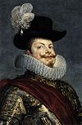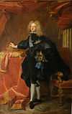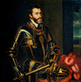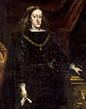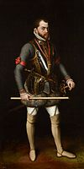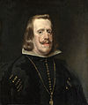House of Habsburg, 1516–1713

Philip II

1598–1621

Philip II

1598–1621

Philip IV

1700–1713

Charles II

1516–1554

Charles III

1665–1700

Philip I

1554–1598

Order the Hasburg Kings in order of who ruled **first**.

House of Trastámara, 1412–1516

Ferdinand II the Catholic

1479–1516

Alfonso the Magnanimous

1416–1458

Joanna the Mad

1516–1555

John the Great

1458–1479

Ferdinand I the Honest

1412–1416

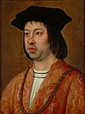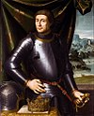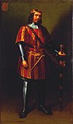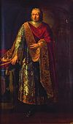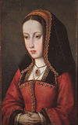

Order the Trastámara Queen and Kings in order of who ruled **last.**

1. Who ruled for the longest period?
2. Who ruled for the shortest period?
3. Did any of the Monarchs rule for the same amount of time?