Capulet’s Extension

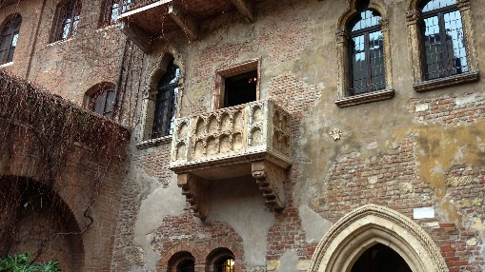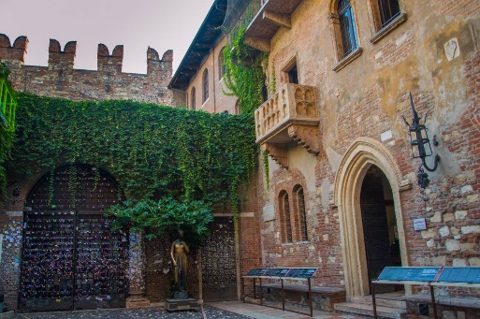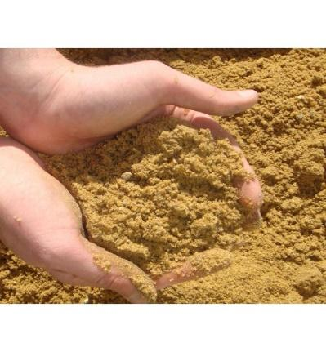Capulet has decided that he wants a larger place to host more parties so he decides to build an extension. Help the builders distribute the stones to the palace where each new room will be.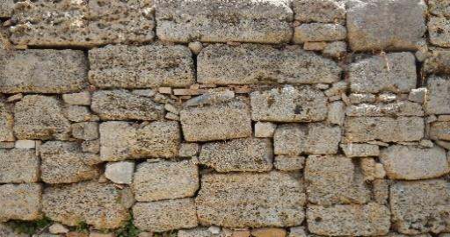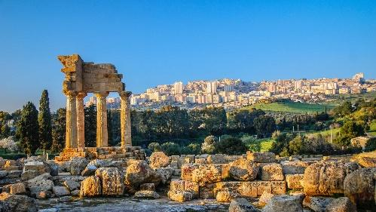

120 stones into 10 rooms

10 bags into 100 rooms

4 bags into 10 rooms

56 bags into 10 rooms

35 bags into 100 rooms

333 bags into 100 rooms

92 bags into 100 rooms

76 bags into 100 rooms

19 bags into 10 rooms

689 bags into 100 rooms

1.5 bags into 10 rooms

21.9 bags into 10 rooms

21.9 bags into 100 rooms

0.8 bag into 10 rooms