Lesson 3: Hermione’s Memories

Context: Hermione sent to prison

In Act 2 Scene 1, Leontes orders Hermione to be imprisoned. By the time she is sent to prison, Hermione has resolved to stay patient and calm until her husband sees reason. However, her emotion and sadness is obvious throughout this scene and is worth looking at in more detail.

Should a villain say so,
The most replenish’d villain in the world,
He were as much more villain: you, my lord,
Do but mistake.

No, by my life.
Privy to none of this. How will this grieve you,
When you shall come to clearer knowledge, that
You thus have publish’d me! Gentle my lord,
You scarce can right me throughly then to say
You did mistake.

Leontes’ anger is also portrayed powerfully throughout this scene:

O thou thing!
Which I’ll not call a creature of thy place,
Lest barbarism, making me the precedent,
Should a like language use to all degrees
And mannerly distinguishment leave out
Betwixt the prince and beggar: I have said
She’s an adulteress; I have said with whom:
More, she’s a traitor

Ask children to look through the scene (from when Leontes first enters until Hermione it taken away) and highlight powerful vocabulary (see examples above) which:
- show how Leontes and Hermione are feeling
- encapsulate the collapse of their relationship

E.g. grief, violent, false, villain, grieve, burns, tears, creature, guilty, weeping

Drama: Freeze Frames
Children get into groups of three. Discuss how much Hermione’s life has changed in recent weeks. Explain that in the drama today they are going to imagine what Hermione and Leontes’ relationship might have been like in the past.
Each pair is given one word from the list above e.g. weeping. They then work together to come up with a contrasting word/action. For example:
weeping – laughing violent – tender grieve – rejoice
grief – happy false – true villain – hero
burns – sooths tears – joy creature – angel
guilty – innocent
Next, each group uses their contrasting word as inspiration for an imagined moment from Leontes and Hermione’s marriage – in role as Hermione. They develop this word into a phrase that describes their freeze frame/or words spoken by Hermione.
e.g. laughing at his terrible jokes
the tender touch of my husband’s hand
rejoicing when our son took his first steps
the happy sound of your voice at the door
You are my one true love!

Groups are given time to practise their freeze frames and then perform to rest of class. Additional adult (TA/teacher) to record phrases on flip chart to be used later in writing lesson.
Writing: Poem in role
N.B. Before writing lesson (perhaps on a previous day) – show children ‘I come from…’ poem by Robert Seatter:
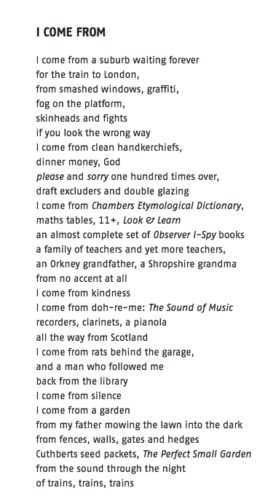
Discuss poem from previous lesson and explain that children are going to write a similar list poem in role as Hermione, showing the contrast between her present situation and her past, happy relationship with Leontes.
Model how each line should combine a happy memory with a contrasting negative word to show her confusion and unfortunate state.
N.B. Don’t use directly contrasting words - mix up to create more interesting combinations.
Possible model for first few lines of poem:
I come from the tender touch of my husband’s grieving hand
Guilty laughter at his terrible jokes
His happy voice at the door destroys my burning soul
I come from a true love turned sour.

Success Criteria:

- first person
- contrasting negative/positive powerful words used in each line
- repeated use of ‘I come from…’

Support children by providing positive / negative word bank. Children should also use ideas developed in drama and recorded on flip art as inspiration.

Negative | Positive
venom  infected  violent  false  villain  grieve  grief  traitor  burns  tears  guilty | medicine  healthy  tender  true  hero  rejoice  happiness  loyal  soothes  laughs  innocent

