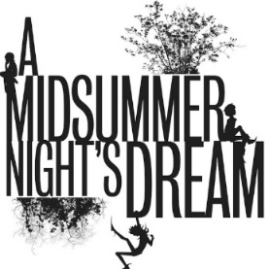

Science Curriculum Objectives & Ideas
Year 3 Objectives | Plants | Animals, including Humans
 | - identify and describe the functions of different parts of flowering plants: roots, stem/trunk, leaves and flowers  - explore the requirements of plants for life and growth (air, light, water, nutrients from soil, and room to grow) and how they vary from plant to plant  - investigate the way in which water is transported within plants  - explore the part that flowers play in the life cycle of flowering plants, including pollination, seed formation and seed dispersal | - identify that animals, including humans, need the right types and amount of nutrition, and that they cannot make their own food; they get nutrition from what they eat  - identify that humans and some other animals have skeletons and muscles for support, protection and movement
Year 3 Ideas | -Identify and describe the functions of flower mentioned in the text (see below)  -In groups, investigate the flowers from the text – think about their life cycles  -Make comparisons between the different flowers in the text  ‘I know a bank where the wild thyme blows,  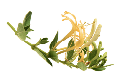  Where oxlips and the nodding violet grows,  Quite over-canopied with luscious woodbine,  With sweet musk-roses and with eglantine:  There sleeps Titania sometime of the night,  Lull'd in these flowers with dances and delight’  [Act II Scene I Line 249]  These are all wild flowers – musk roses are Rosa arvensis, and eglantine is R. rubiginosa. Woodbine is an old name for honeysuckle | -Pupils to create a project on donkeys. Class is split into groups and each group takes a different type of donkey, which they must present on.  -Write an information booklet on donkeys.  -Draw a skeleton of a donkey in the style of George Stubb’s 1757 ‘Anatomical Drawings’.  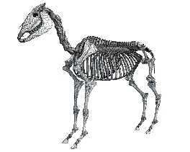  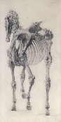
Year 4 Objectives | Living Things and their Habitats |  | Sound
 | - recognise that living things can be grouped in a variety of ways  - explore and use classification keys to help group, identify and name a variety of living things in their local and wider environment  - recognise that environments can change and that this can sometimes pose dangers to living things |  | - identify how sounds are made, associating some of them with something vibrating  - recognise that vibrations from sounds travel through a medium to the ear  - find patterns between the pitch of a sound and features of the object that produced it  - find patterns between the volume of a sound and the strength of the vibrations that produced it  - recognise that sounds get fainter as the distance from the sound source increases
Year 4 Ideas | Create a classification key of the flowers in the play: wild thyme, oxlips, violet grows, woodbine (honeysuckle), musk-roses and eglantine:  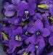  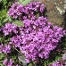  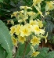  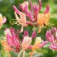  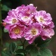  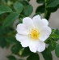  -Create a classification key of equidaes, i,e, horses, donkeys, mules, ponies etc. www.stem.org.uk/system/files/community-resources/legacy_files_migrated/11563-ANIMALS%20AND%20THEIR%20HABITATS%20KS2%20PRESENTATION.pdf |  | -Explore sound in the context theatre/orchestra  -Think about how acoustics in Shakespeare plays have changed through time and what the difference in an amphitheatre might be  -Test out different locations in the school, where would the sound be best and why?  Websites with useful information/experiments that can be linked to theatre/orchestra sound:  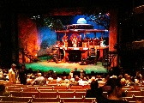  -Glossary of theatre technical terms www.theatrecrafts.com/pages/home/topics/sound/glossary/  -www.dramatoolkit.co.uk/drama-strategies/soundscape  -www.bbc.com/teach/class-clips-video/music--science-ks2-what-is-sound/zbnmhbk  -Some further sound investigation ideas: www.cryptschool.org/images/general/teachingschool/sound-and-light-booklet-crypt-teaching-school.pdf  www.hamilton-trust.org.uk/science/year-4-science/sound-listen/
Year 5 Objectives | Living Things and their Habitats | Earth and Space
 | - describe the differences in the life cycles of a mammal, an amphibian, an insect and a bird  - describe the life process of reproduction in some plants and animals | - describe the movement of the Earth and other planets relative to the sun in the solar system  - describe the movement of the moon relative to the Earth  - describe the sun, Earth and moon as approximately spherical bodies  - use the idea of the Earth’s rotation to explain day and night and the apparent movement of the sun across the sky
Year 5 Ideas | -Pupils to create a visual representation of the lifecycle of a donkey  -Compare the donkey with amphibians, insects and birds  -See https://donkeysanctuary.org/en/donkeys/donkeys-on-bonaire/50-donkey-facts for some facts  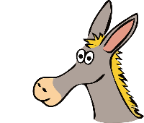 | 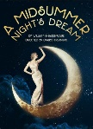  The importance the moon is in A Midsummer Night's Dream is high. The moon is used to mark the passage of time. In Theseus's opening speech, he complains that time is passing too slowly and he blames the moon because he has to wait four whole days for his wedding night:  Shakespeare manages to turn the moon into a  joke about the use of theater props. During  rehearsals for Pyramus and Thisbe,Peter  Quince worries about whether or not the moon will shine during the night of the performance, because Pyramus and Thisbe are supposed to "meet by moonlight" (3.1.45)  - www.cliffsnotes.com/literature/m/a-midsummer-nights-dream/critical-essays/moon-imagery
Year 6 Objectives | Living Things and their Habitats | Evolution and Inheritance
 | - describe how living things are classified into broad groups according to common observable characteristics and based on similarities and differences, including micro-organisms, plants and animals  - give reasons for classifying plants and animals based on specific characteristics | - recognise that living things have changed over time and that fossils provide information about living things that inhabited the Earth millions of years ago  - recognise that living things produce offspring of the same kind, but normally offspring vary and are not identical to their parents  - identify how animals and plants are adapted to suit their environment in different ways and that adaptation may lead to evolution
Year 6 Ideas | -Create study of equidaes, i,e, horses, donkeys, mules, ponies etc.  -Create classification key of flowers in the play: wild thyme, oxlips, violet grows, woodbine (honeysuckle), musk-roses and eglantine. Give reasons for the classification.  -www.stem.org.uk/system/files/community-resources/legacy_files_migrated/11563-ANIMALS%20AND%20THEIR%20HABITATS%20KS2%20PRESENTATION.pdf | -Research the evolution of equidaes. How have fossils helped scientists to understand the evolution?  -Create a comic strip, which focus on the changes of a donkey through time.  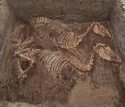  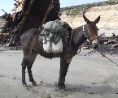  -Think about hybrid animals, i.e. a mule is the offspring of a male donkey and a female horse. www.luckythreeranch.com/lucky-three-ranch-training/mule-facts/  -Research and answer questions on donkey classification, www.stem.org.uk/system/files/community-resources/legacy_files_migrated/11565-ANIMALS%20AND%20THEIR%20HABITATS%20KS2%20TEACHER%20GUIDE.pdf  ‘Donkey. The donkey or ass (Equus africanus asinus) is a domesticated member of the horse family, Equidae. The wild ancestor of the donkey is the African wild ass, E. africanus. The donkey has been used as a working animal for at least 5000 years.’

