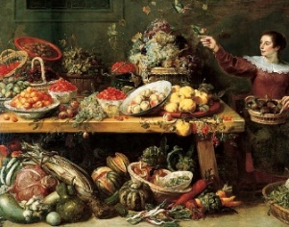Multiply the Ingredients

Leontes is so overcome with joy that Hermione, his wife is alive again that he decides to have

a romantic meal with her, prepared by his servants. They don’t have much time to prepare

and need your help to work out the quantities of ingredients that they will need.

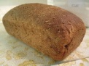For the bread:

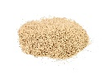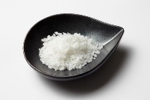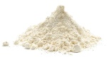

327 x 8g of salt =

311 x 2g of salt =

415 x 9g of flour =

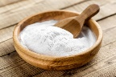

146 x 47ml of warm water =

381 x 16g of baking soda =

421 x 18ml of milk =

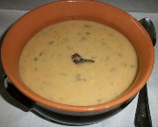

For the Maccu Soup:

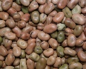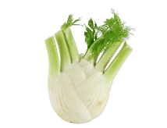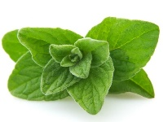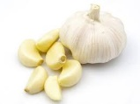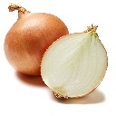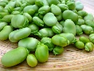

901 x 17g of fennel =

831 x 28g of oregano =

612 x 18g of garlic =

591 x 42g of onion =

651 x 61g of beans =

508 x 54g of fava beans =

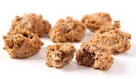

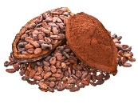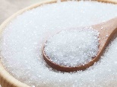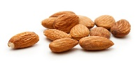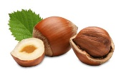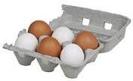For the Bruttiboni:

2421 x 55g of cocoa =

2160 x 94g of vanilla=

3187 x 38g of sugar =

1923 x 64g of almonds =

2012 x 73g hazelnuts =

1171 x 28 eggs =