Convert the Distance
A mile is roughly equal to 1.5 kilometres (km)
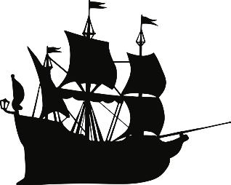

- It took Antigonus 17 miles to walk from the coast to the woodland with baby Perdita. How many kilometres was the walk?

- Florizel and Perdita went for a long, romantic stroll together. There and back was 24 km. How many miles was it?

- Polixenes rushed to escape Sicily. The entire journey was 230 miles. How many km was the trip?

- In a year, Mamillius ran around the palace’s enormous garden, which added-up to a total of 995 km! How far is this in miles?

- It took lords Dion and Cleomenes 246 miles to travel from Delphi to Sicily. How many km did it take?

- It takes Prince Florizel and his new wife Perdita 1024 km travel from Bohemia to Sicily. How many miles did it take?

- Challenge – Camillo and Archidamus debate how far it is from Sicily to Bohemia. Camillo thinks it’s 1200 miles. Whereas Archidamus thinks it’s 1985 kilometers. Who thinks the distance is longest?

- Write your own conversion problem for a partner.

