Twelfth Night
Act 4
Year 3 and 4 noble household perimeters

Context

Olivia’s jester Feste is sent to find Cesario and instead stumbles across Viola’s brother, Sebastian. Sebastian is confused as Feste pretends to know him and he offers him money to go away.

Sir Andrew and Sir Toby attack Sebastian believing him to be Cesario. As they begin to fight, Olivia arrives and angrily demands the men to stop. Mistaking him for Cesario, she invites Sebastian to her house. Although he is confused, he enjoys her attention and gladly accompanies her.

Locked away in a dark room, Feste visits Malvolio disguised as a priest. He tries to convince Malvolio of his own madness and the servant pleads with him to deliver a letter to Olivia.

Sebastian walks around Olivia’s house confused as to why this beautiful woman wants to marry him. He wonders where his friend Antonio is so that he can discuss the matter with him. Before this can happen, Olivia arrives with a priest and Sebastian agrees to marry Olivia before him.

Maths

The household of the noblewoman Olivia inspires this activity.

LI: To measure the perimeter of simple 2D shapes (Y3)
LI: To measure and calculate the perimeter of a rectangular figure (including squares) (Y4)

The Household of Olivia
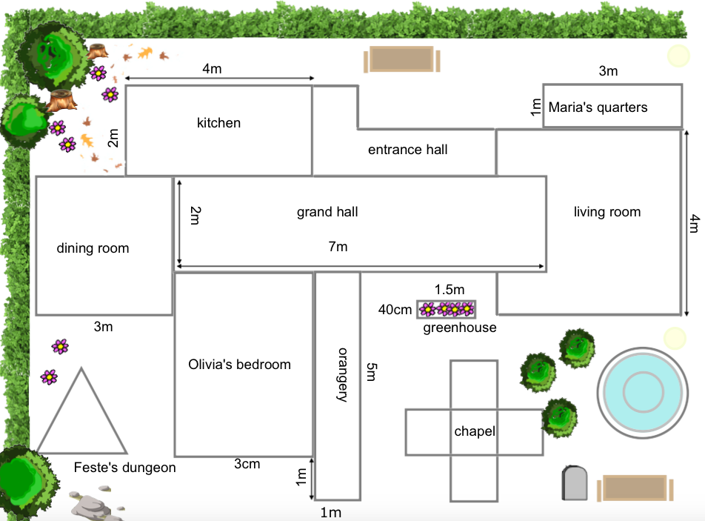
Questions

- What is the perimeter of the kitchen?

- What is the perimeter of Maria’s quarters?

- What is the perimeter of the dining room?

- what is the perimeter of Olivia’s bedroom?

- the perimeter of the living room is bigger/ smaller/ the same as the grand hall. Circle the correct answer.

- The total length of two of the sides of Feste’s dungeon is 6m. what is the total perimeter?

- True or false? The kitchen and the entrance hall have the same perimeter.

- Olivia plans to build a games room for her new husband. She plans to make it square-shaped. In the design, each of the sides are whole in metres. Which of the following could be the perimeter?

4m, 16m, 18m, 25m, 32m

- Duke Orsino’s chapel shape is made from 5 identical squares arranged exactly like Olivia’s chapel. The perimeter of the whole building is 24m. Find the perimeter of the central square.

- All the sides of the orangery are whole, odd numbers. Is the perimeter even or odd? can you solve this without looking at the measurements?

- What is the perimeter of the greenhouse in cm and m?

Answers

- 12m

- 8m

- 12m

- 14m

- grand hall – 18m living room – 18m
they are the same

- 6 ÷2 = 3 3 x 3 = 9m
= 9m

- true

- 4m / 16m/ 32m

- 24 ÷ 12 = 2 2 x 4 = 8m
= 8 m

- even (odd + odd + odd + odd is always even)

- 3.8m or 380cm

