National Curriculum
Recognise that living things produce offspring of the same kind, but normally offspring vary and are not identical to their parents.
Working Scientifically
- Recording data and results of increasing complexity using scientific diagrams and labels, classification keys, tables, scatter graphs, bar and line graphs
- Reporting and presenting findings from enquiries, including conclusions, causal relationships and explanations of and degree of trust in results, in oral and written forms such as displays and other presentations
- Identifying scientific evidence that has been used to support or refute ideas or arguments.
Key scientific concepts:
- Understand how living things produce offspring of the same kind, but these offspring vary and are not identical to their parents or each other
- Know that some things, such as skills, talents or behaviors, are not passed from a parent to its offspring genetically and must be learned
Context: Facts we learn about Viola: She has a twin brother called Sebastian who she believes drowned in the shipwreck she herself survived. The Captain helps her to disguise herself as a young man called 'Cesario' and get a job in Orsino's house. She is resilient and resourceful. In Twelfth Night, identical twins provide the basis for foils, doubles, misprised identity, and gender confusion.
Lesson 1: To identify inherited and non-inherited traits.
- Watch the video- create a table of inherited and non-inherited traits. (Activity 1)
- Collect information from peers on their traits. (Activity 2 (a) Use this data to create a bar graph. (Activity 2b)
- Analysis the data- what have you learnt about your class? Write a short summary about your findings. Answer the question.
Lesson 2: To examine characteristics inherited by offspring
- Look at pictures of celebrities and their children. Can you identify what they have inherited? (Activity 3) discuss what has been inherited.
- Complete royal family inherited traits. (Activity 4)
- Non inherited traits- how could the twins be different? (Activity 5)
- Share your findings.
Lesson 3: To investigate my inherited and non-inherited traits
- Class (in pairs) to look in the mirror and discuss inherited traits
- Create a brace map with a peer. (Activity 6)
- Chn to write a list of individual non-inherited traits (skills, talents and behaviors) and compare them with their pair. What non inherited traits does Viola demonstrate?(Activity 7)
*use the thinking frames examples for guidance

Activity 1
https://www.bbc.co.uk/bitesize/topics/zvhhvcw/articles/z4vhxbk
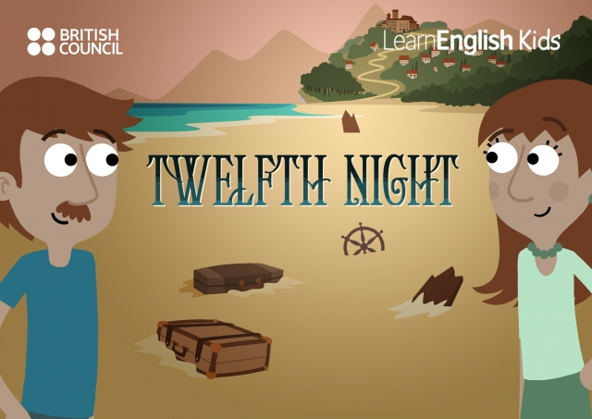
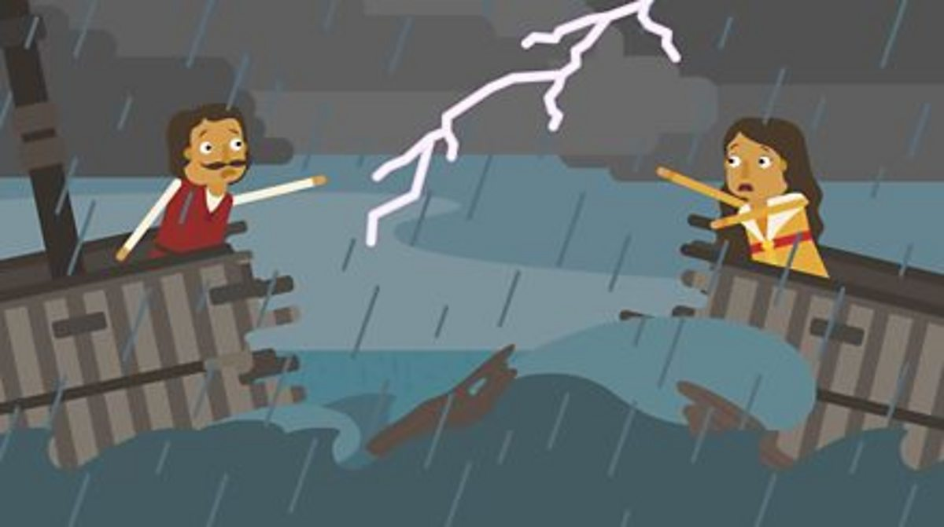
Inherited traits | Non-inherited traits

Activity 2a- Our Class Traits
Traits- inherited | Tally
Right handed
Left handed
Can roll tongue
Cannot roll tongue
Blue eyes
Brown eyes
Another colour
Dimples
No Dimples
Findings:
________________________________________________________________________________________________________________________________________________________________________________________________________________________________
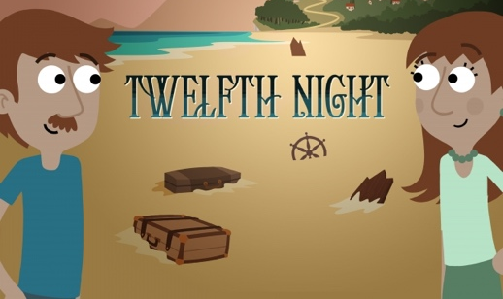
Do you think identical twins would have the same traits? Explain.

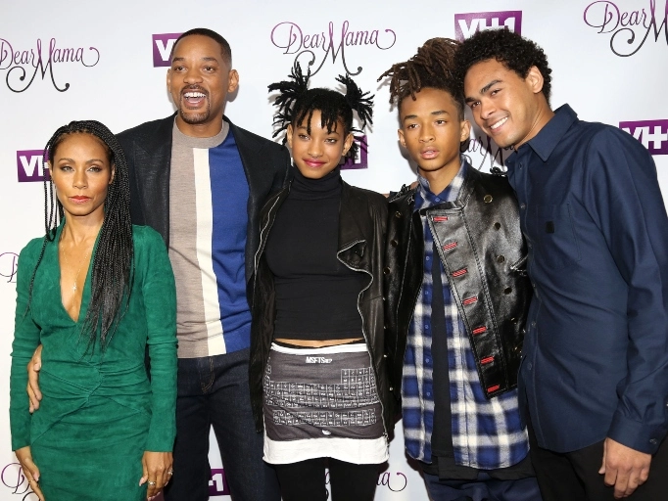
Activity 3

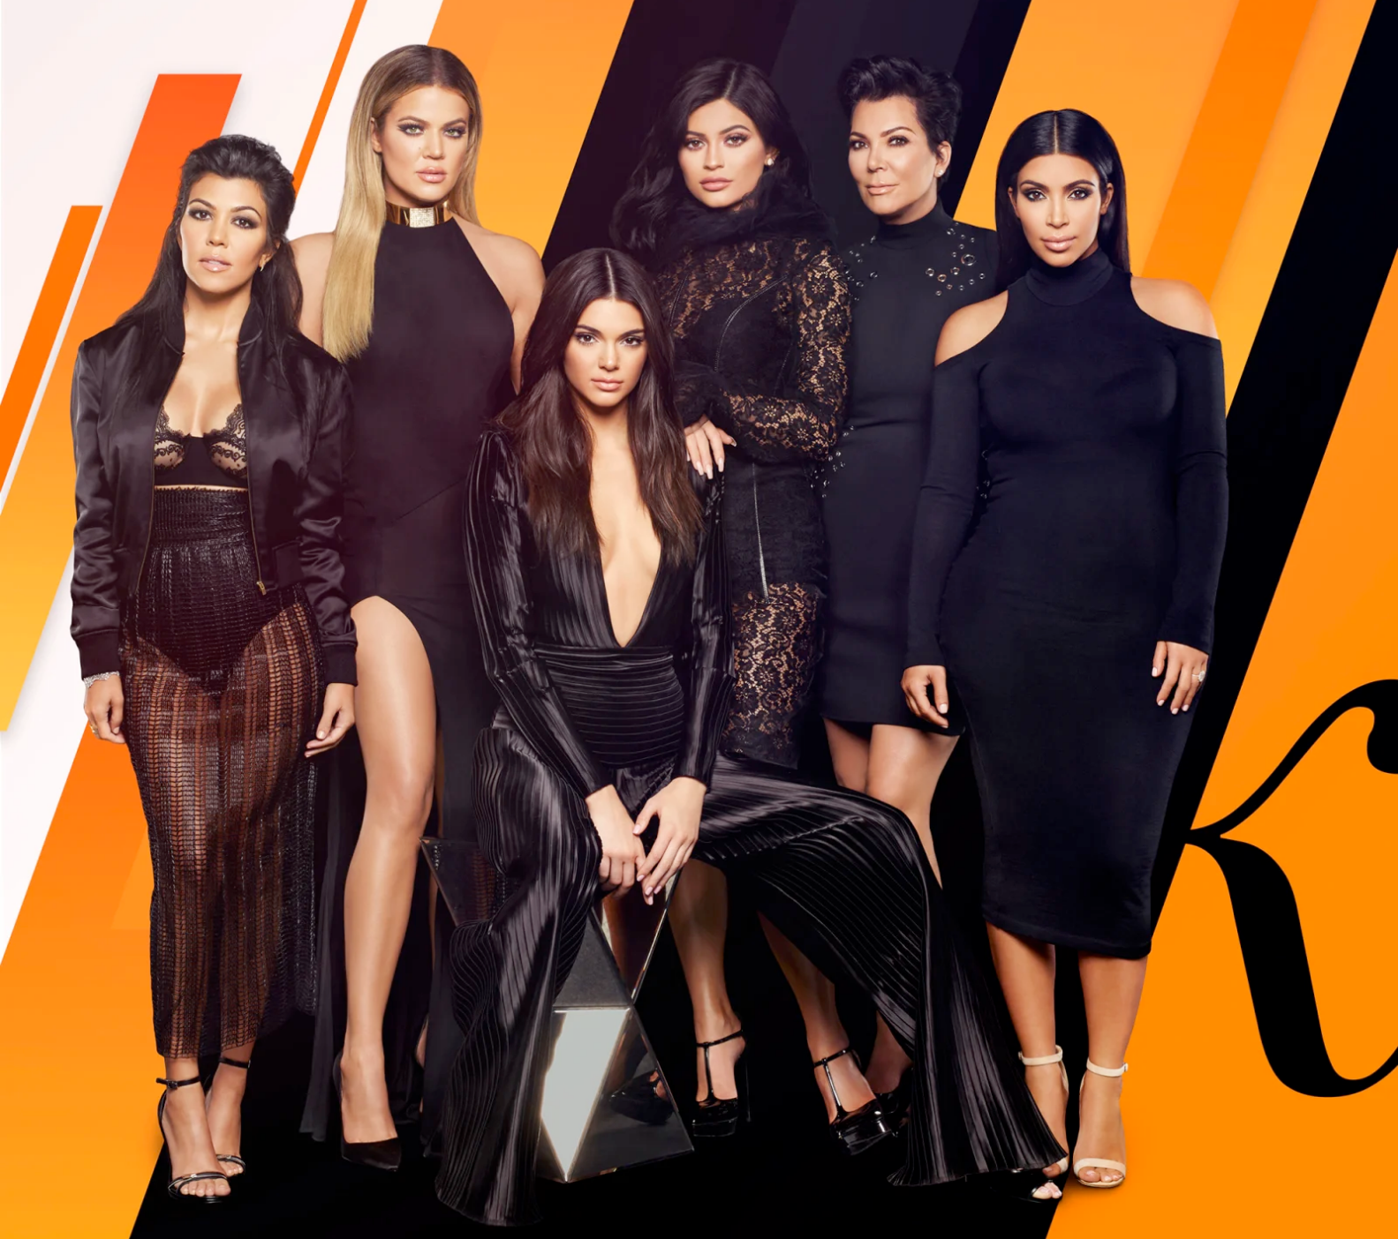
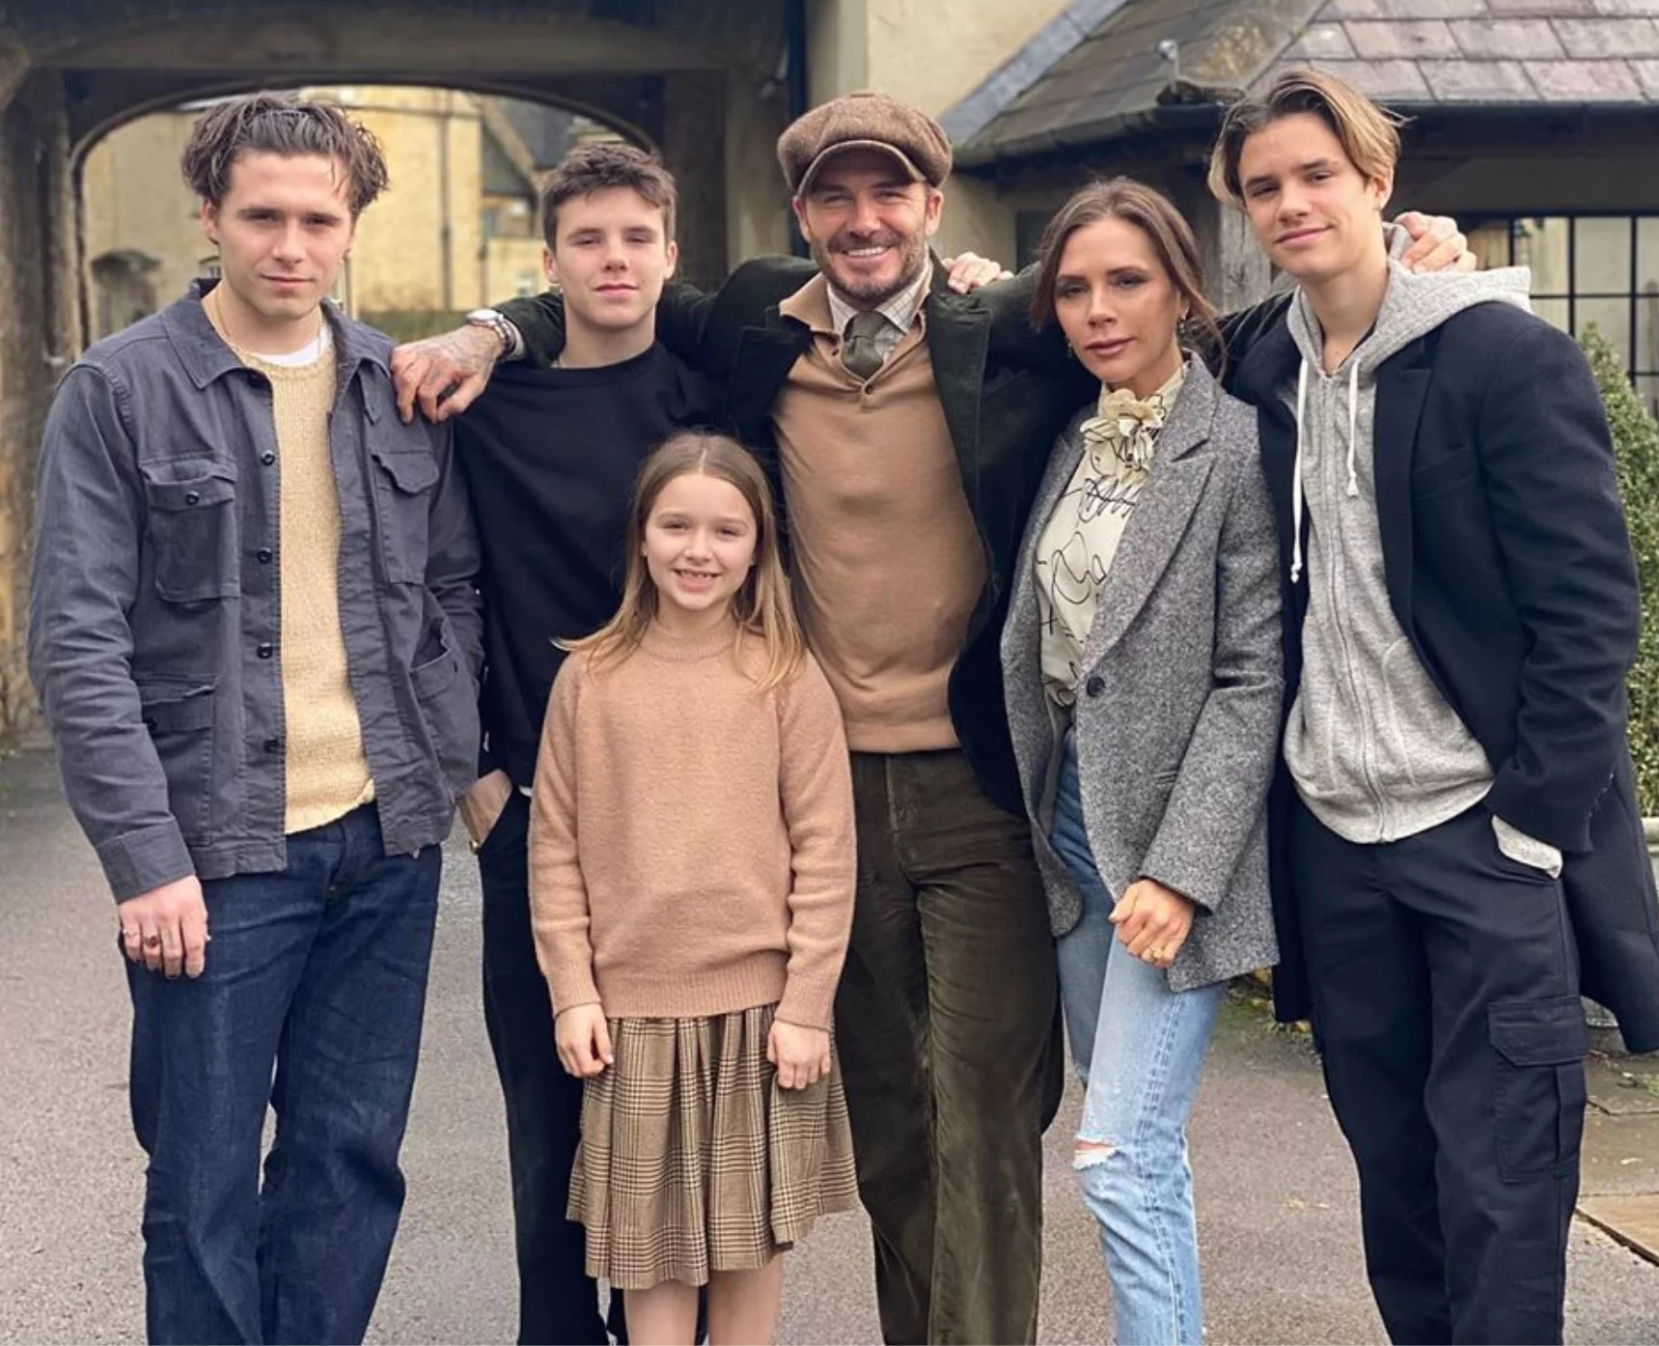

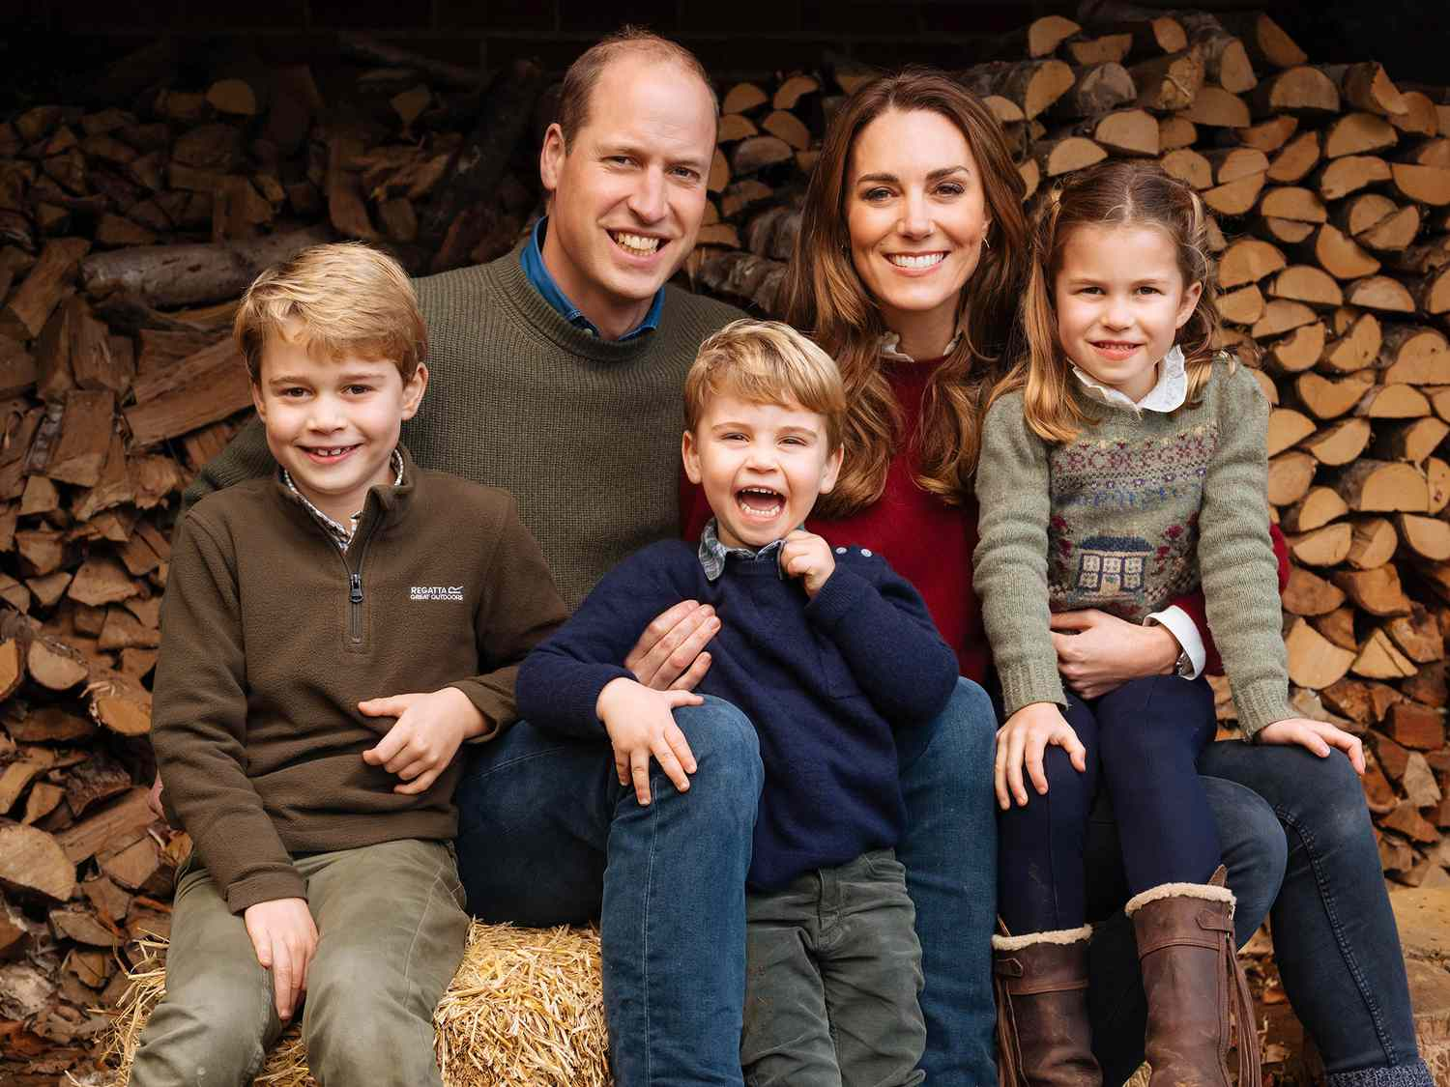

Activity 4

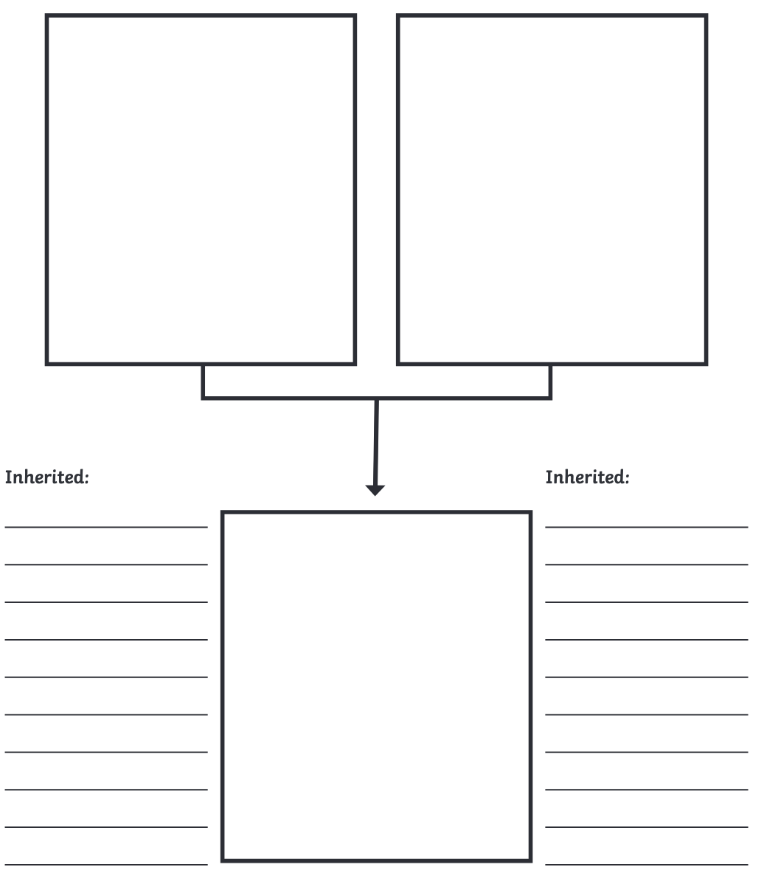
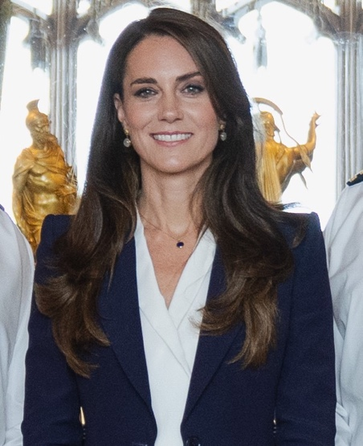
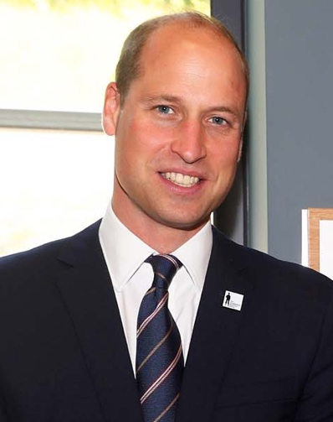
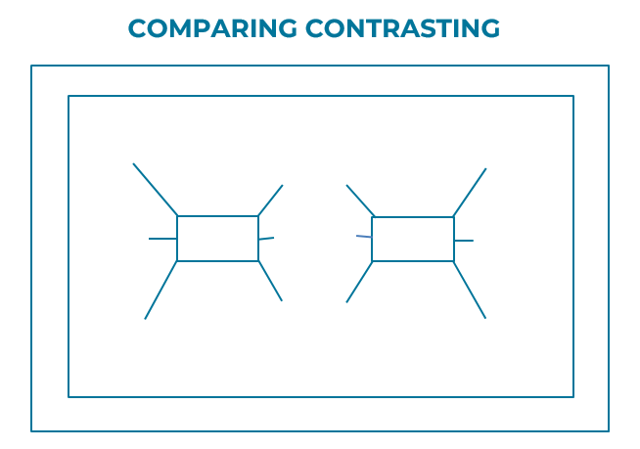
Activity 5

Activity 6

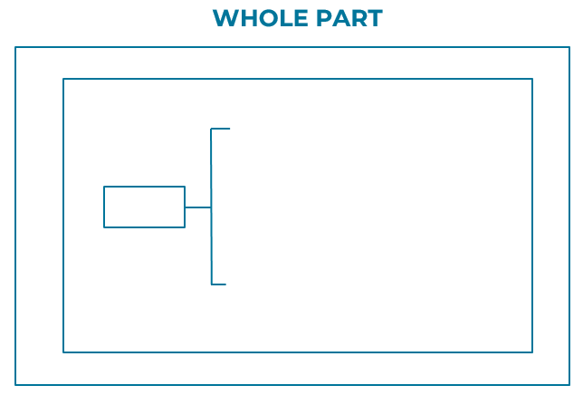

Thinking frames examples
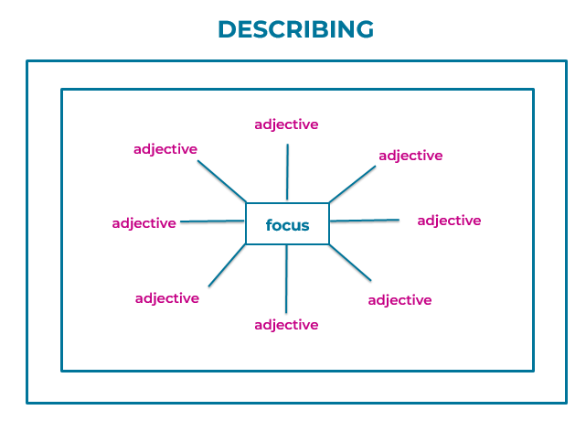
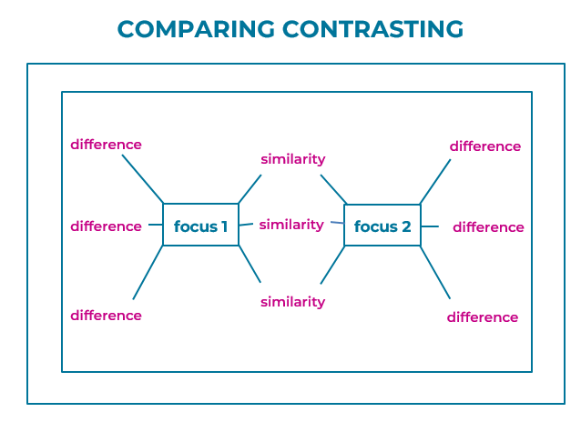
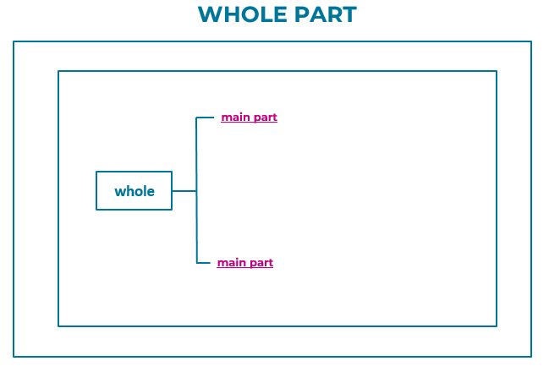

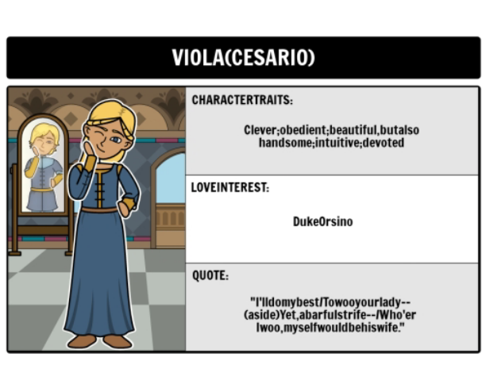
Activity 7

What no inherited traits does Viola demonstrate?

Traits | Example
Clever
Obedient
Devoted
Intuitive

What character non inherited character traits did Sebastian demonstrate?
_______
______
________

Activity 2b

