Juliet, Paris and Romeo are in a love triangle. Every love triangle is different. Theirs

has an area of 12cm2. Write the area of each triangle within its heart.

Colour any triangles (not the heart) that could belong to Juliet, Paris

and Romeo…

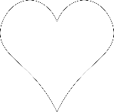

4cm

4cm

6cm



4cm



2cm

1cm

2cm

4cm

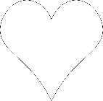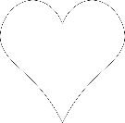

5cm

3cm

3cm

3cm

3cm

6cm

5cm

10cm

9cm

10cm

7cm

4cm

3cm

8cm

2cm

5cm