Global Volcanism
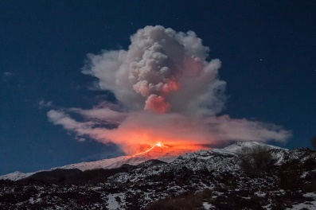
Mount Etna in Sicily is an active volcano. Here is a bar chart showing
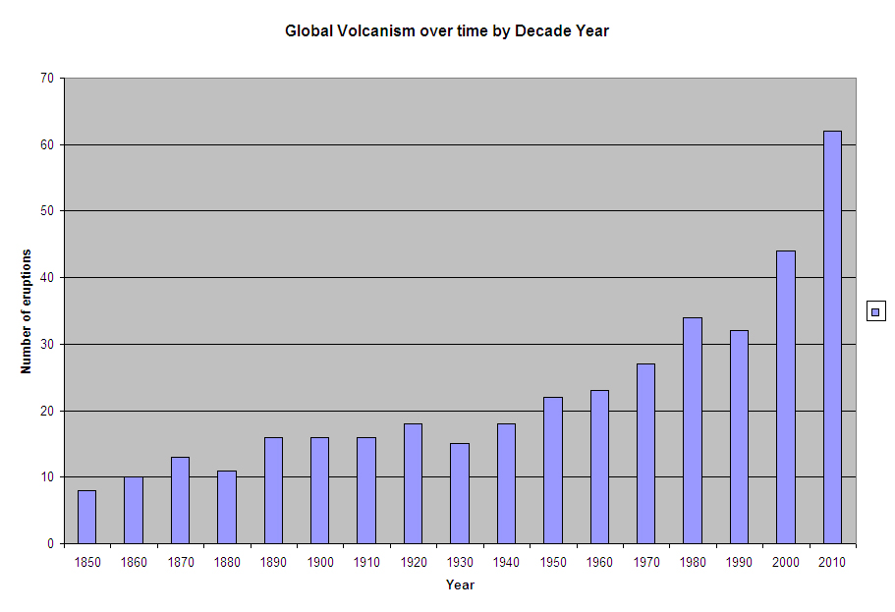
historical volcanic activty across the world.

- Which decade were there most eruptions?

- Which decade were there least eruptions?

- How many eruptions were there in 1860?

- Which 3 decades were there the same amount of eruptions?

- Which are the 3 decades that have less eruptions than the previous decades?

- Why do you think that generally there are more eruptions as time goes on?

- Can you ask 2 of your own questions about the bar chart?

