The Palace Extension

[](https://www.google.co.uk/url?sa=i&rct=j&q=&esrc=s&source=images&cd=&cad=rja&uact=8&ved=0ahUKEwiNwa-JgN_YAhXECsAKHaKPAAoQjRwIBw&url=http://theshakespeareblog.com/2013/05/looking-at-leontes-the-winters-tale-in-stitches-at-the-rsc/&psig=AOvVaw0jar1Pw15zm318920bAV6Z&ust=1516278575667991)[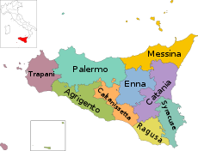](https://www.google.co.uk/url?sa=i&rct=j&q=&esrc=s&source=images&cd=&cad=rja&uact=8&ved=0ahUKEwiulp31_d7YAhWlC8AKHR38AlIQjRwIBw&url=https://en.wikipedia.org/wiki/Sicily&psig=AOvVaw3EMuccxUSNcLk2QDQ7GNyt&ust=1516277956235654)[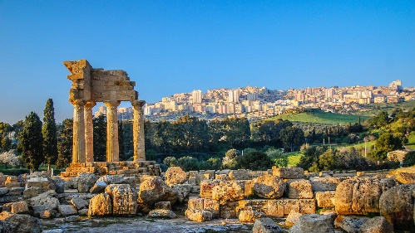](https://www.google.co.uk/url?sa=i&rct=j&q=&esrc=s&source=images&cd=&cad=rja&uact=8&ved=0ahUKEwif9cjh_d7YAhVCDMAKHWdIAT4QjRwIBw&url=http://www.kuoni.co.uk/italy/sicily/hotels&psig=AOvVaw3EMuccxUSNcLk2QDQ7GNyt&ust=1516277956235654)[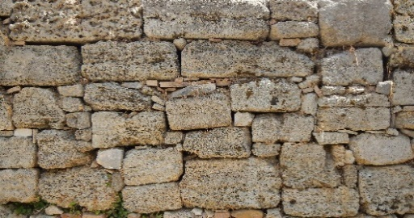](https://www.google.co.uk/url?sa=i&rct=j&q=&esrc=s&source=images&cd=&cad=rja&uact=8&ved=0ahUKEwi3-PaI-d7YAhURUlAKHX-UAMgQjRwIBw&url=http://www.lughertexture.com/stone-plates-and-ornaments-textures-download/medieval-stone-blocks-texture&psig=AOvVaw178Sd6zYAa8OT-S-UG427s&ust=1516276711975553)[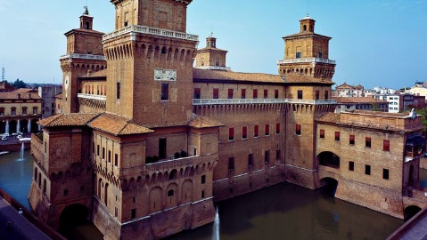](https://www.google.co.uk/url?sa=i&rct=j&q=&esrc=s&source=images&cd=&cad=rja&uact=8&ved=0ahUKEwjquIjV-N7YAhUJaFAKHdrMD9EQjRwIBw&url=https://www.pinterest.com/pin/368239707009217224/&psig=AOvVaw1ZwKRbg2FbQGo_Q2unNdaj&ust=1516276598980319)Leontes has decided that he wants a larger palace so he decides to build an extension. Help the builders distribute the stones to the place where each new room will be.

1. 21 stones into 3 rooms.
2. 25 stones into 5 rooms.
3. 32 stones into 8 rooms.
4. 36 stones into 9 rooms.
5. 48 stones into 8 rooms.
6. 81 stones into 9 rooms.
7. 132 stones into 12 rooms.
8. 120 stones into 10 rooms.
9. 60 stones into 5 rooms.
10. 40 stones into 5 rooms.
11. 66 stones into 6 rooms.
12. 72 stones into 9 rooms.
13. 49 stones into 7 rooms.