Mount Etna Climograph
Climograph showing the temperature and the rainfall on Mount Etna
(over a 1 year period)
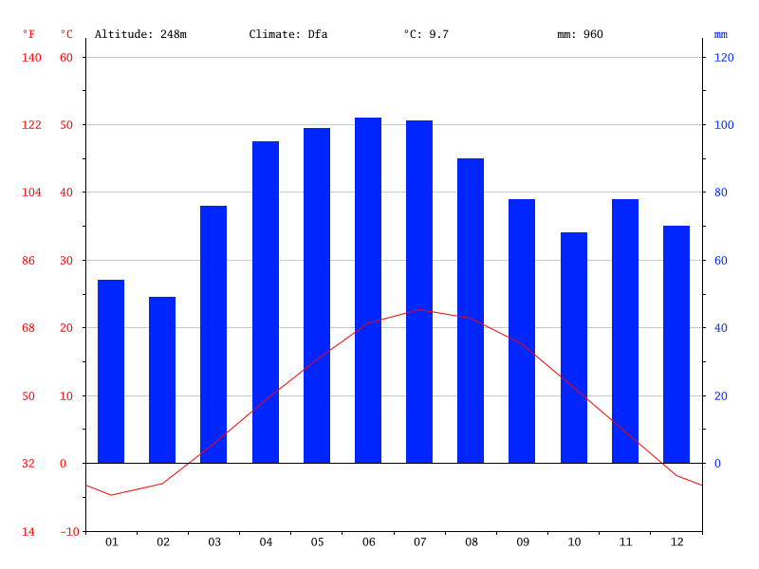
01 – January
02 – February
03 – March
04 – April
05 – May
06 – June
07 – July
08 – August
09 – September
10 – October
11 – November
12 - December

temp (c)

rainfall (mm)

month

- What is the mean rainfall in Spring?

- What is the mean rainfall in Summer?

- What is the mean rainfall in Autumn?

- What is the mean rainfall in Winter?

- Which month saw the least rainfall?

- Which two months had the same rainfall?

- What months would the rain water have frozen?

- In which month was there the biggest difference between the rainfall and the temperature?

Can you ask your own questions about the climograph?

