Multiply the Wedding Feast Ingredients

In Act 4, Juliet tells her parents she will marry Paris. Lady Capulet is so excited and demands the servants plan a fabulous feast. They don’t have much time to prepare and need your help to work out the quantities of ingredients that they will need.

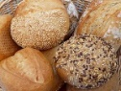For the bread:

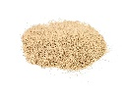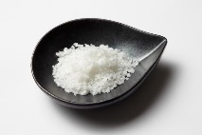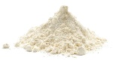

327 x 81g of salt =

311 x 27g of salt =

415 x 39g of flour =

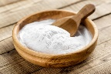

146 x 47ml of warm water =

381 x 16g of baking soda =

421 x 18ml of milk =

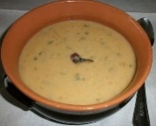

For the soup:

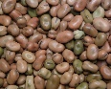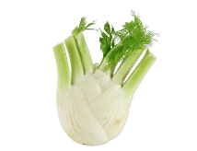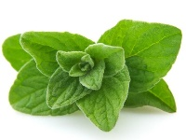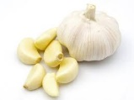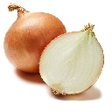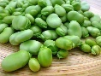

2901 x 17g of fennel =

8319 x 28g of oregano =

6612 x 18g of garlic =

1591 x 42g of onion =

2651 x 61g of beans =

9508 x 54g of fava beans =

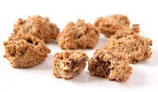

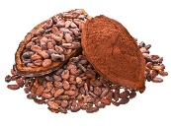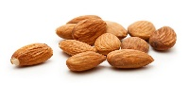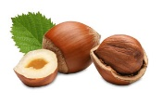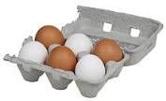For the bruttiboni (cake):

2421 x 55g of cocoa =

2160 x 94g of vanilla=

3187 x 38g of sugar =

1923 x 64g of almonds =

2012 x 73g hazelnuts =

1171 x 28 eggs =