Athens Royalty

Erechtheid dynasty (first 6)

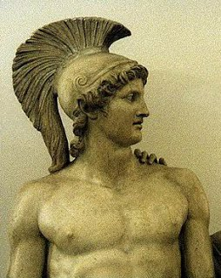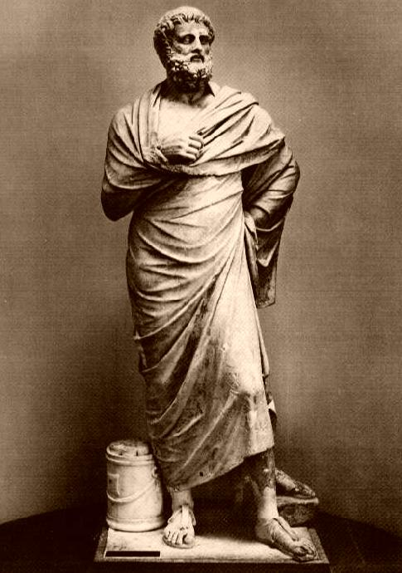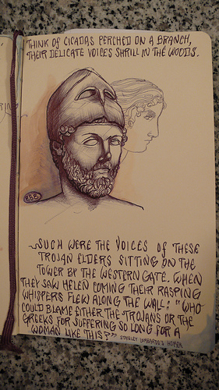

Demophon

1183–1150 BC

Theseus

1234–1205 BC

Oxyntes

1150–1136 BC

Menestheus

1205–1183 BC

Thymoetes

1135–1127 BC

Apheidas

1136–1135 BC

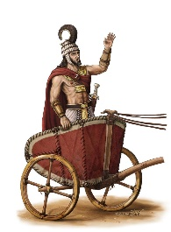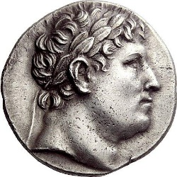

Order the Erechtheid dynasty in order of who ruled **first**.

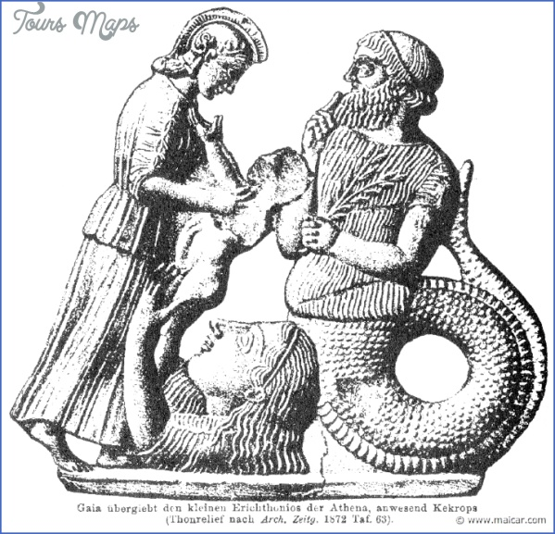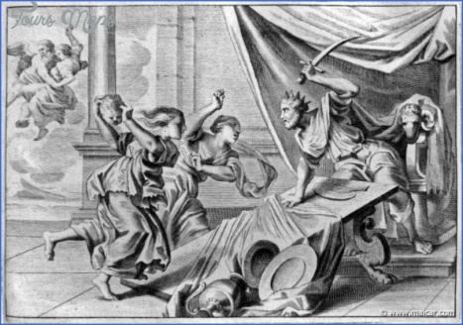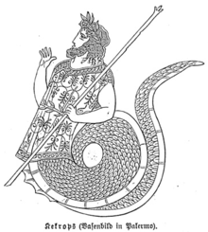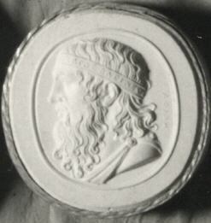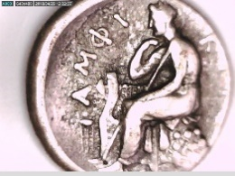Erechtheid dynasty (most recent 6)

Cranaus

1506–1497 BC

Cecrops II

1347–1307 BC

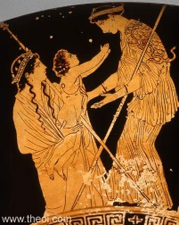

Erichthonius

1487–1437 BC

Pandion I

1437–1397 BC

Cecrops I

1556–1506 BC

Amphictyon1

1497–1487 BC

Order the Erechtheid dynasty in order of who ruled **last.**

1. Who ruled for the longest period?
2. Who ruled for the shortest period?
3. Did any of the Monarchs rule for the same amount of time?