Flower Fractions
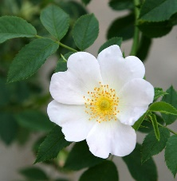
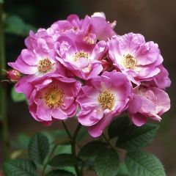
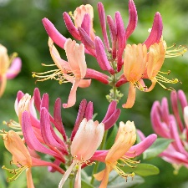
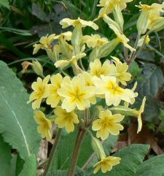
Sometimes Shakespeare uses flowers descriptively, to create a scene in the mind of the audience. For example, in A Midsummer Night’s Dream, Oberon, King of the Fairies, is talking to his messenger Puck about where Queen Titania is sleeping:

I know a bank where the wild thyme blows,
Where oxlips and the nodding violet grows,
Quite over-canopied with luscious woodbine,
oxslip
With sweet musk-roses and with eglantine:
honeysuckle
R. rubiginosa
rosa arvensis
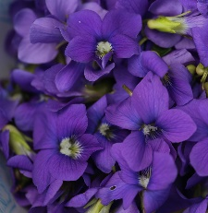
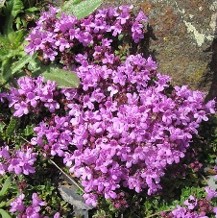
There sleeps Titania sometime of the night,
Lull'd in these flowers with dances and delight;
[Act II Scene I Line 249]
These are all wild flowers – musk roses are Rosa arvensis, and eglantine is R. rubiginosa. Woodbine is an old name for honeysuckle.

violets
wild thyme

Colour the petals of the wild flowers that are equivalent to the fraction in the middle.
$$\frac{5}{10}$$

$$\frac{12}{25}$$

$$\frac{16}{32}$$

$$\frac{8}{16}$$

$$\frac{75}{150}$$

½
$$\frac{100}{200}$$

$$\frac{3}{9}$$

$$\frac{10}{30}$$

$$\frac{2}{8}$$

$$\frac{16}{32}$$

$$\frac{2}{7}$$

$$\frac{8}{16}$$

$$\frac{3}{12}$$

$$\frac{3}{7}$$

$$\frac{5}{15}$$

$$\frac{2}{6}$$

$$\frac{1}{3}$$

$$\frac{1}{4}$$

$$\frac{11}{44}$$

$$\frac{4}{12}$$

$$\frac{6}{18}$$

$$\frac{4}{8}$$

$$\frac{7}{29}$$

$$\frac{12}{48}$$

$$\frac{6}{32}$$

$$\frac{5}{16}$$

$$\frac{12}{18}$$

$$\frac{5}{25}$$

Now create three flowers of your own with a fraction in the middle, some equivalent fractions in the petals and some that are not. Try and add some tenths and hundredths. Ask a partner to shade the petals with an equivalent fraction.
$$\frac{20}{30}$$

$$\frac{2}{5}$$

$$\frac{4}{25}$$

$$\frac{10}{30}$$

$$\frac{2}{10}$$

$$\frac{14}{21}$$

$$\frac{15}{20}$$

$$\frac{4}{20}$$

$$\frac{3}{18}$$
=
$$\frac{3}{7}$$

$$\frac{16}{21}$$

$$\frac{3}{5}$$

$$\frac{2}{3}$$

$$\frac{6}{30}$$

$$\frac{1}{5}$$

$$\frac{4}{6}$$

