Round the Facts!
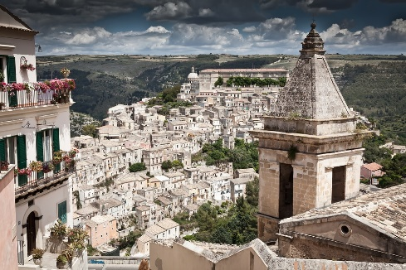

- The area of Bohemia is 20,100 sq miles. Round to the nearest 1000.

- This is 52,060 km². Round to the nearest 100.

- The area of Sicily is 9,927 sq miles. Round to the nearest 1000.

- This is 25,710 km². Round to the nearest 100.

- Mount Etna in Sicily is 3,329 m high. Round this to the nearest 10.

- This is 10,922 ft high. Round to the nearest 10,000.

- Sicily has a total costal length of 922 miles. Round to the nearest 10.

- This is 1,484 km. Round to the nearest 100.

- The Salso river in Sicily is 143231.6 in length. Round to the nearest whole number.

- The river Elbe runs through Bohemia and is 1091135.2 meters long. Round this to the nearest 100,000.

Challenge:
- Bohemia is now home to 6.5 million people. Round this to the nearest 100,000 and write the answer in numbers and then in words.

- Sicily is now home to 5,048,553. Round this to the nearest 100,000 and write the answer in numbers and then in words.

