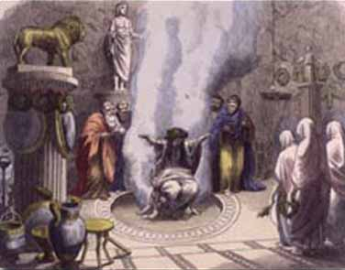
The Oracle of Delphi

The Pythia was the name of the High Priestess of the Temple of Apollo at Delphi who also served as the oracle, commonly known as the Oracle of Delphi.
Here are some predictions that the Oracle made. If the numbers is written in numerals, convert it to words and if the number is written, convert it into numerals.
Example: There will be enough crops to feed 997 people.
Answer: nine hundred and ninety seven
- Greece will reach temperatures of over forty five degrees Celsius.

- The River Elbe will carry two hundred and thirty eight boats this year.

- The next time Mount Etna erupts, it will kill six hundred and two trees.

- In Spring, in Bohemia, 435 calves will be born.

- Sicily will be invaded by 911 people.

- The Grande River will break it’s bank 87 times.

- On Mount Olympus it will snow one hundred and sixty one times.

- Four hundred and nine sperm whales will come close to the Greek Coast.

- Eight hundred and twenty three olive trees will grow in Greece.

- There will be four hundred shooting stars over the Sicilian skies.

Write 4 of your own sentences that include numbers written as words.

