Capulet’s Extension
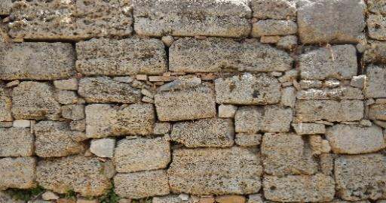
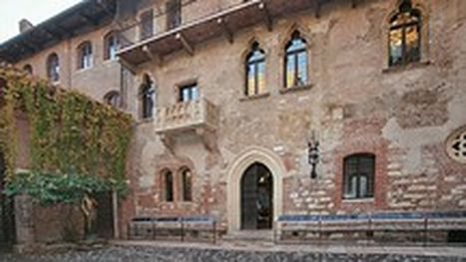
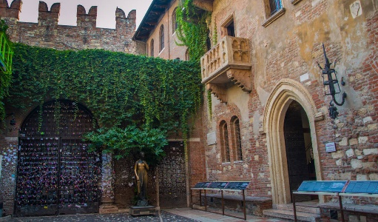
Capulet has decided that he wants a larger place to host more parties so he decides to build an extension. Help the builders distribute the stones to where each new room will be.
870 stones into 6 rooms
276 stones into 4 rooms
721 stones into 7 rooms
435 stones into 5 rooms
333 stones into 9 rooms
992 stones into 8 rooms
820 stones into 4 rooms
936 stones into 6 rooms
1393 stones into 7 rooms
1512 stones into 9 rooms
2168 stones into 8 rooms
1625 stones into 5 rooms
1689 stones into 3 rooms

