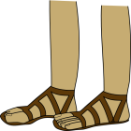
Roman Shoe Problems
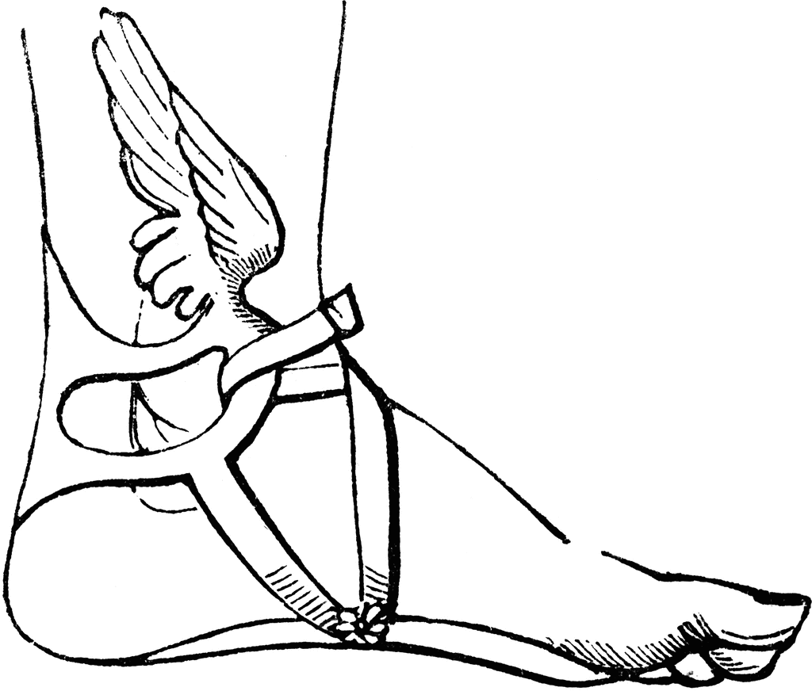
- The cobbler is trying to work out how many pairs of shoes he’s fixed in the month of September. He works out that he fixed 26 pairs each workday and 19 pairs on a Saturday and on a Sunday. How many shoes did he fix altogether in September?

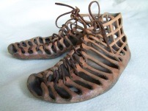
- In his shop, the cobbler has 340 pairs of shoes. He owns 14 shops in neighbouring villages. Each shop has the same number of shoes. How many shoes does he own altogether?

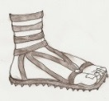
- The cobbler works out his finances for the month. He’s in a pickle and comes out with this sum: 432 ÷ ? = 12 x 9
- How many drachmas has he made?

- He’s done the same for two months. Can you help him again to work out how many drachmas he’s made? 82 x 3 = 500 - ?

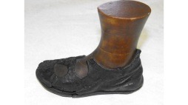
- The cobbler decided that in celebration of Lupercal, he’d fix the people’s sandals for free. 968 people bring him their shoes. He can fix 5 pairs an hour. How many hours will it take him to fix all 968 pairs?

- The cobbler is tired. He’s already mended half of the 968 pairs of shoes but for the other half, he can only manage 2.5 pairs an hour. How many hours will it take him to fix the remaining shoes?

- The cobbler needs 1015m of brown leather to create 350 pairs of shoes. He needs to make 700 pairs of shoes. How much leather will he need?

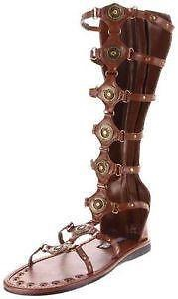
- The cobbler works for 456 minutes in week 1, 336 minutes in week 2 and 678 minutes in week 3. How many hours does he work altogether?

