A cast are preparing to put on a performance of Romeo and Juliet but first, they need to get the numbers in order…

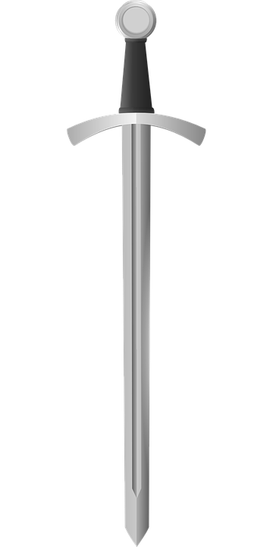
Act 1, Scene 1 - Montague V Capulet brawl
In the Act 1 fight in July, swords were swung a total of 198436 times.
In a previous fight in June, swords were swung a total of 193231 times.
In a previous fight in May, swords were swung a total of 189415 times.
In a previous fight in April, swords were swung a total of 171442 times.
In a previous fight in March, swords were swung a total of 171397 times.
Order which month had the least sword swings to the month that had the most.
……………………… ……………………… ……………………… ……………………… ………………………

Act 1, Scene 2 – The Invitation
Peter is asked to deliver invitations to the Capulet feast for Paris to try and win Juliet’s heart.
He takes them to 4 different districts in Verona: Veronetta, Valdonega, Borgo Roma
And San Zeno.
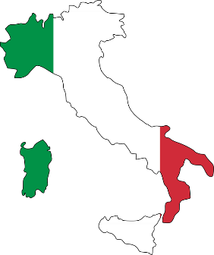
To Veronetta, Peter delivers 102189 invitations.
To Valdonega, Peter delivers 134191 invitations.
To Borgo Roma, Peter delivers 211881 invitations.
To San Zeno, Peter delivers 200198 invitations.

Order the districts. Start with the district that had most invitations delivered.

……………………… ……………………… ……………………… ………………………

Act 1, Scene 3, - The Feast –
- ………………………………………

- ………………………………………

- ………………………………………

- ………………………………………

- ………………………………………

- ………………………………………

- ……………………………………...

- ………………………………………

- ………………………………………

- ………………………………………
The cooks to pre-order the food items for the next year. Put the
food items for the next years’ feasts in order, from: 1. Dishes that
they need the most of - 10. Dishes that they need the least of…
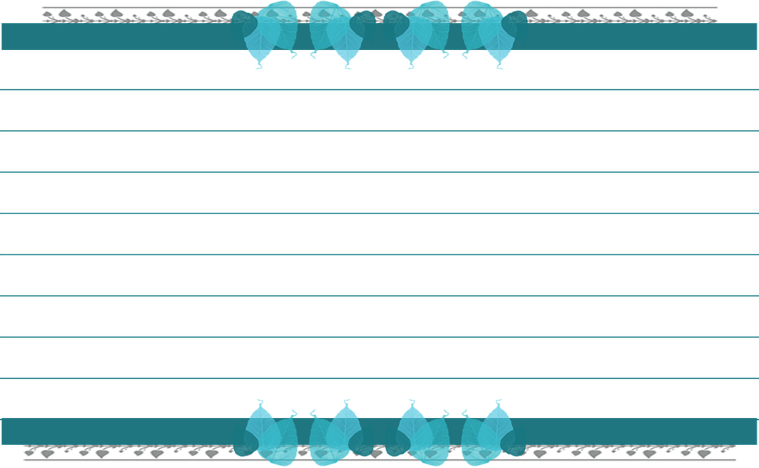
Portions of raspberry pudding 321682

Bowls of oxtail soup 231504

Baked pies 341779

Oysters 231876

Slices of almond cake 121897

Bowls of gooseberry fool 321719

Bowls of mixed cooked greens 231907

Fresh bread rolls 211812

Roasted venison 121754

Boiled mutton 231681

