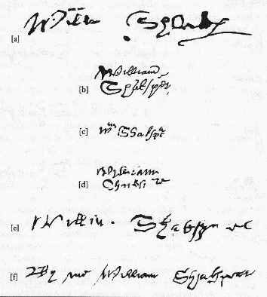
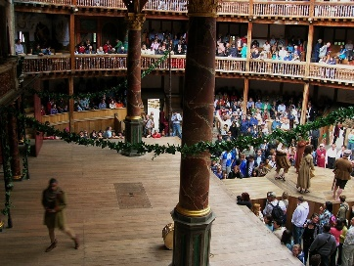
Facts about Shakespeare

- There are more than LXXX variations recorded for the spelling of Shakespeare’s name.

- If Shakespeare was alive today, he’d be turning CDLIII years old in 2018!

- Shakespeare was LII years old when he died.

- Shakespeare’s plays contain CC references to dogs

- …and DC references to birds!

- He wrote CLIV sonnets.

- The builders of The Globe had to measure more than M oak trees to build Shakespeare’s Globe.

- Although there are no records, some people think that Shakespeare was probably educated at the King's New School in Stratford, which was CDXII meters from his home.

- Different sources state different things but some think that Shakespeare’s works have been translated into CIV languages.

- Challenge – The Winter’s Tale was first performed in MDCXI.

- Challenge – Shakespeare was born in MDLXIV.

- Challenge - The word ‘love’ appears MMCXCI times in the complete works.

