
Convert the Times

- The second half of the play, takes place after 16 years! How long is this in months?

- It takes Prince Florizel and his new wife Perdita 6 weeks to travel from Bohemia to Sicily as they stop to see some sights. How many days did it take them?

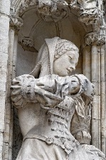
- It took a craftsperson 73 hours to create a statue of Hermione. How many minutes did it take to create?

- Polixenes rushed to escape Sicily. It took him 43 minutes to board the ship. How many seconds did it take him to board?

- Mamillius has fallen ill. He is ill for 21 days. How many hours is he ill for?

- Baby Perdita was alone in the woodland until the Shepherd found her. She was alone for 1500 seconds. How many minutes was she on her own for?

- It took the Oracle of Delphi 29 minutes to make a divine verdict. How many seconds did it take?

- It took lords Dion and Cleomenes 4 and a half days to return from Delphi. How many hours did it take?

- Challenge - Hermione was pregnant for exactly 9 months, from 1st July – 31st March. How many days was she pregnant for?

- Challenge – How many hours was she pregnant for?

