Multiply the Ingredients for the Wedding Feast

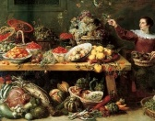The four lovers and Bottom leave the forest believing this to all have been a midsummer nights dream. The tedious play is performed at the wedding feast where Lysander and Hermia, Demetrius and Helena and Theseus and Hippolta get married.

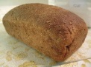For the bread:

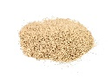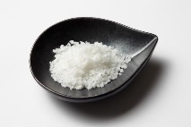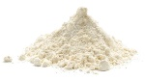

37 x 8g of salt =

31 x 2g of salt =

45 x 9g of flour =

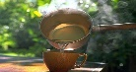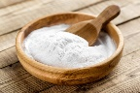

46 x 7ml of warm water =

38 x 6g of baking soda =

42 x 8ml of milk =

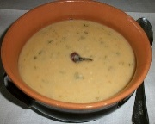

For the Maccu Soup:

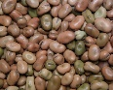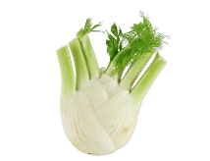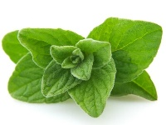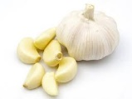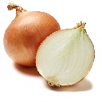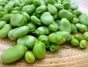

90 x 7g of fennel =

83 x 8g of oregano =

61 x 8g of garlic =

59 x 4g of onion =

65 x 6g of beans =

50 x 4g of fava beans =

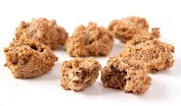

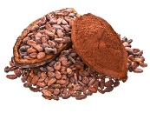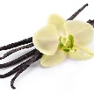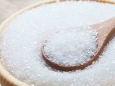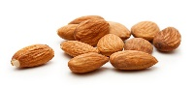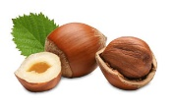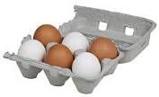For the Bruttiboni:

24 x 5g of cocoa =

21 x 4g of vanilla=

187 x 8g of sugar =

192 x 4g of almonds =

201 x 3g hazelnuts =

117 x 8 eggs =