The Palace Extension
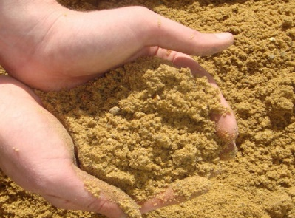
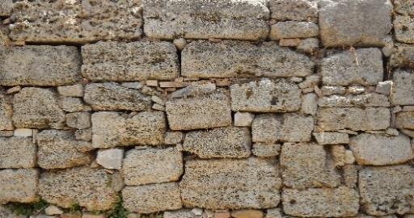

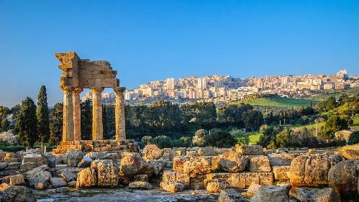
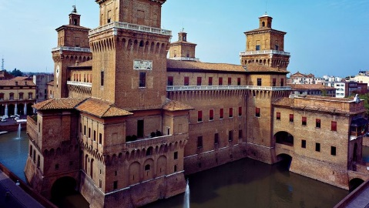
Leontes has decided that he wants a larger palace so he decides to build an extension. Help the builders divi
- 0.8 bag into 10 rooms.
- 21.9 bags into 100 rooms.
- 21.9 bags into 10 rooms.
- 1.5 bags into 10 rooms.
- 689 bags into 100 rooms.
- 19 bags into 10 rooms.
- 76 bags into 100 rooms.
- 92 bags into 100 rooms.
- 333 bags into 100 rooms.
- 10 bags into 100 rooms.
- 35 bags into 100 rooms.
- 56 bags into 10 rooms.
- 4 bags into 10 rooms.
de t
he bags of sand correctly to the place where each new room will be.

