Twelfth Night
Act 1
Year 5 and 6 LOVE TRIANGLES
Context

The play is set in the kingdom of Illyria. A nobleman named Orsino is in love with Lady Olivia, a noblewoman. Despite his affections, she is mourning the death of her brother and refuses to consider his many marriage proposals or even meet him. Meanwhile, a ship has been wrecked on the shores of Illyria after a huge storm. Viola, a beautiful aristocratic woman, finds herself in an unknown place. She is without her twin brother Sebastian, who has been her travel companion on-board. Assuming the worst, she decides he must have drowned and that she must now therefore find work in Illyria to support herself.

Viola meets a friendly sailor who tells her about Duke Orsino’s desire for Olivia. She sets hopes on working for the noblewoman, but discovers that Lady Olivia refuses to meet with any strangers. Feeling she has no other choice, she decides to disguise herself as a man, take the name of Cesario and go to work for Orsino instead.

Dressed as Cesario, Viola soon becomes Orsino’s page and favourite. She begins to fall in love with him. Orsino however thinks she is a man and asks Cesario to deliver his messages of love to the aloof Olivia. In a twist of events, Olivia falls in-love with the beautiful, young messenger Cesario, unknowing that he is actually Viola.

Maths

This angles in triangles investigation is inspired by the love triangle between Orsino, Viola (Cesario) and Olivia that emerges at the end of this act.

LI: To measure angles in degrees (º) (Y5)

To find unknown angles in triangles (Y6)

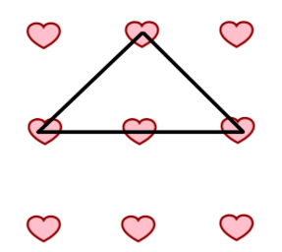
Rules

- Use 3 straight lines only to draw a triangle
- Each line must go from a heart to a heart
- Only use the 9 heart board as it is arranged below
- The same shaped triangle placed in a different position counts as a different triangle

Questions

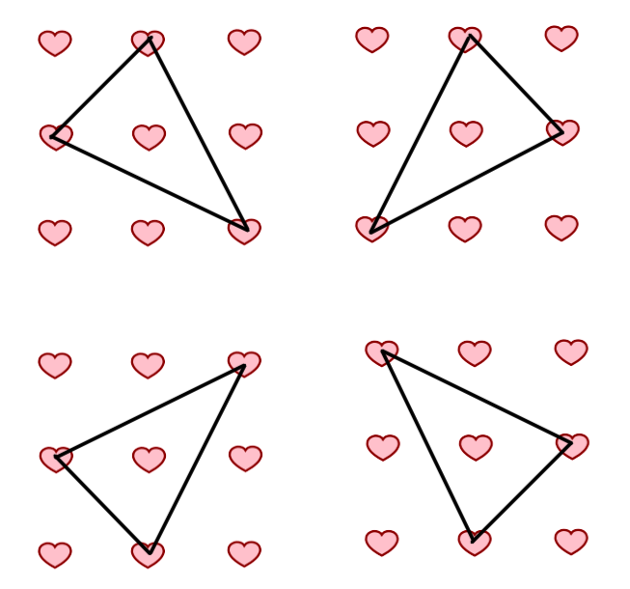
How many different triangles can you make using 3 straight lines between 9 hearts?

Which type of triangle can you make the most of? Isosceles? Right-angled? Scalene? Equilateral? Which triangle has the largest angle? Smallest?

Can you measure the angles in the different triangles? What do you notice?

Teacher Tips

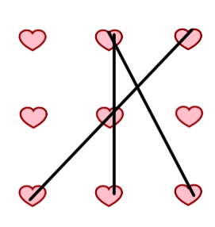
Provide the children with the prepared dotted paper attached to record their different attempts.

Extension

Some triangles do not have their vertices on the hearts but can still obey the rules. How many new triangles can you make? Can you be sure you have made them all?

Solutions
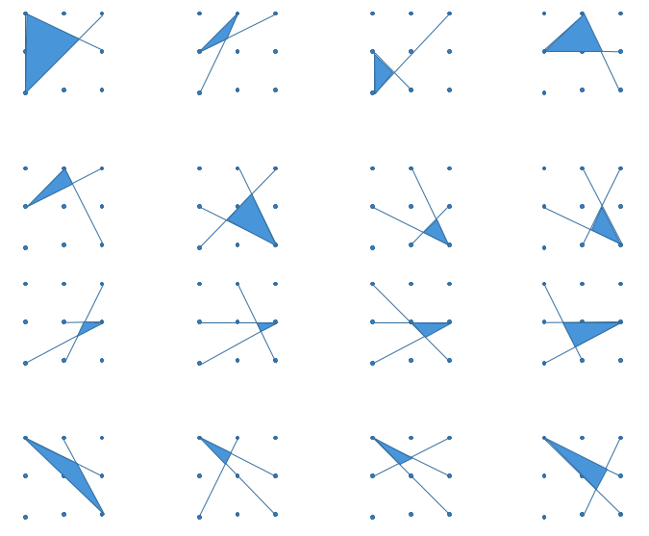

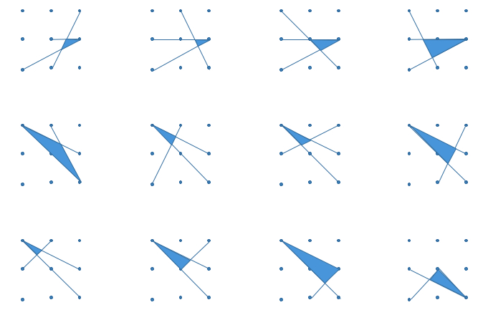
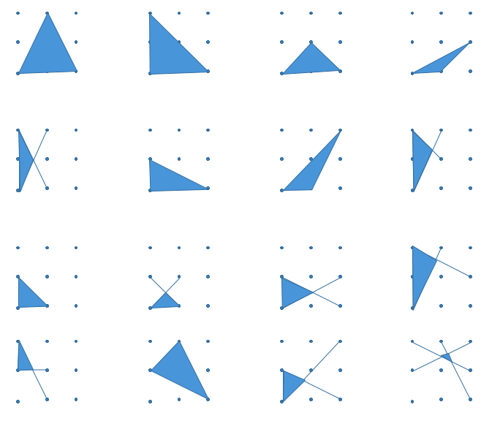

Based on Tri.’s by Nrich

